
Bi-Monthly Restorative Review
  - Department Newsletter March-April 2026
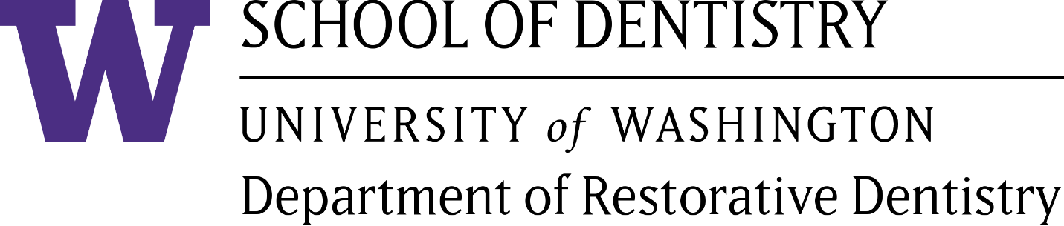


Welcome!

Academy of Operative Dentistry

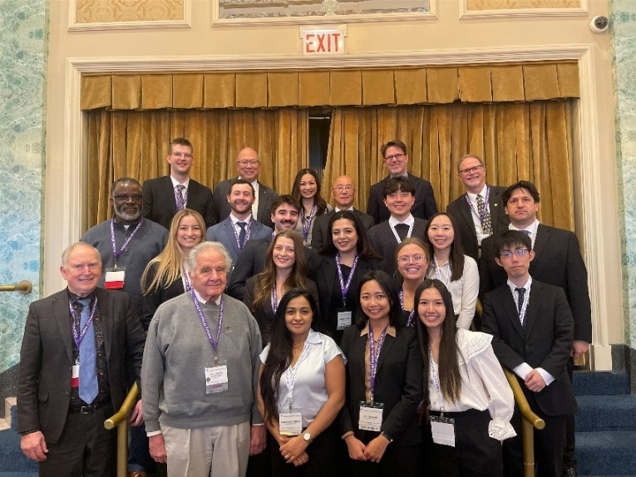
The Academy of Operative Dentistry hosted another very successful meeting in Chicago. 12 dental students and several dental school faculty members attended the meeting held on Thursday, February 19th at the Drake Hotel. This Academy has deep roots at UWSOD, with many of our faculty and alumni as past and present presidents, as well as managing editor of the Operative journal. Dr. Marty Anderson has held both positions and for many years has funded our student travel fund. Our school had the most delegates, with twelve 4th year students as well as faculty, including Dean Ritter, Drs. Anderson, Sadr, Yae, Tucker, Hess, Redd, Maebo, and Chianglin.
Students and faculty at the AOD meeting

Pacific Northwest Gnathologic Study Club

The Pacific Northwest Gnathologic Study Club continues to champion excellence in advanced dental education by generously supporting the University of Washington School of Dentistry (UWSOD) Graduate Prosthodontics program.

Through dedicated leadership and collective generosity, the PNGSC raised an impressive $8,500 this year, directly enhancing resident training, program resources, and hands-on learning opportunities. We extend special thanks to Dr. Keith Phillips, this year's keynote speaker for the Ralph Yuodelis Lectureship, who kindly donated his entire honorarium back to the program. His selfless contribution beautifully reflects the spirit of mentorship and commitment that defines our community.

This enduring partnership between the PNGSC and UWSOD underscores a shared passion for elevating prosthodontic education and delivering exceptional patient care. We are deeply grateful for the ongoing support that fuels the next generation of specialists.

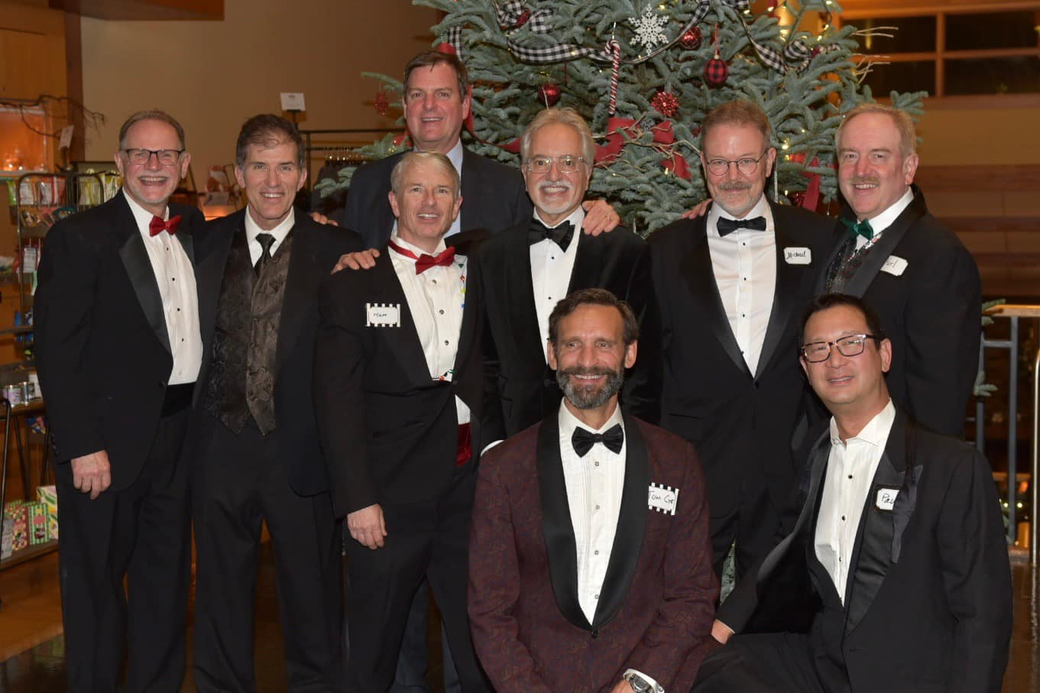
Founded in 1993 under the mentorship of Dr. Olin Loomis, the PNGSC has long been a driving force in gnathology and restorative dentistry. Our members have held prominent leadership roles in prestigious organizations, including the American Academy of Restorative Dentistry (AARD), Academy of Operative Dentistry (AOD), American Academy of Gold Foil Operators (AAGO), the Tucker Institute, and the International Academy of Gnathology (IAG), with several serving as affiliates at the University of Washington. Our second mentor was Dr. Robert Nishikawa USC ’73 (retired) and our current mentor since 2024 is Dr. Timothy Hess (UWSOD ’94).

In 2023, we proudly evolved into a teaching-focused study club, welcoming new members and expanding our impact. We convene 10 times per year at the Washington AGD Global Learning Center in SeaTac, where we host renowned lecturers and deliver interactive, hands-on courses that bridge theory and practice.

Mark your calendars for the 2026 UWSOD Graduate Prosthodontics Annual Ralph Yuodelis Lectureship on Friday, June 12, 2026, at the Washington AGD Global Learning Center. This signature event promises another day of cutting-edge insights and inspiration.
UWSOD alumni at the PNGSC

Pictured above are proud alumni from the UWSOD Class of 1990 (L to R, back row: Charlie Young, Phil Redd, Brian Filbert, Matt Pilot, Frank Calvo, Michael Flatley, Karl Hoffman; front row: Tom Cyr, Paul Hasegawa). For me, being part of this vibrant study club has truly been the highlight of my professional career – fostering lifelong learning, collaboration, and excellence in dentistry. Other members from UW include Clark Redd ’91, Lisa Kajimura ’94, Jesse Boyett ’94, Eric McRory ’95, Joe Hwang ’97 and Jencen Robey ’23. We have several members from other dental schools.

For more information on our courses and events, visit: https://www.gnathologyusa.org/ce_courses/
-Karl L. Hoffman, DDS
President, Pacific Northwest Gnathologic Study Club

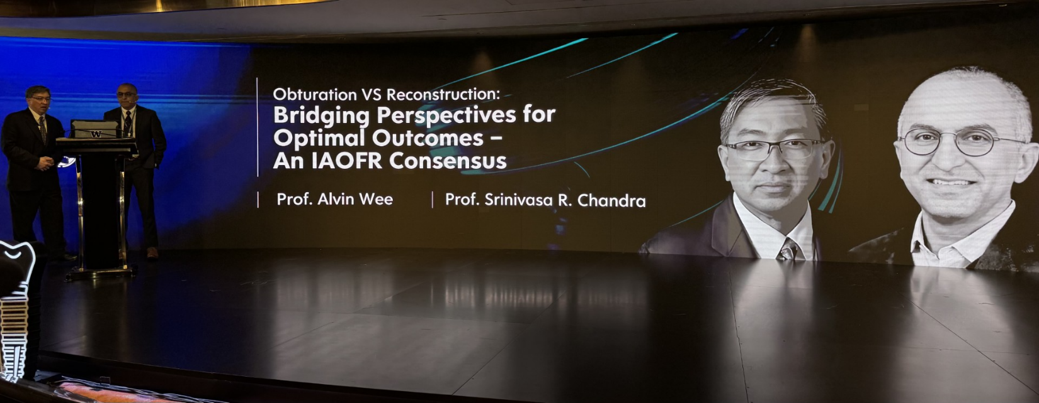
Spreading the UW Name Around the World
Dr. Wee (left) and Dr. Chandra (right) presenting in Hong Kong

On March 24th and 25th, Dr. Alvin Wee gave a presentation together with Dr. Srini Chandra (OMS) at the new Academy of Oral and Maxillofacial Implantologist (AOMI) Global Foundation meeting and Scientific Symposium, Hong Kong. The presentation was titled “Obturation vs. Reconstruction: Bridging Perspectives for Optimal Outcomes – An IAOFR Consensus."

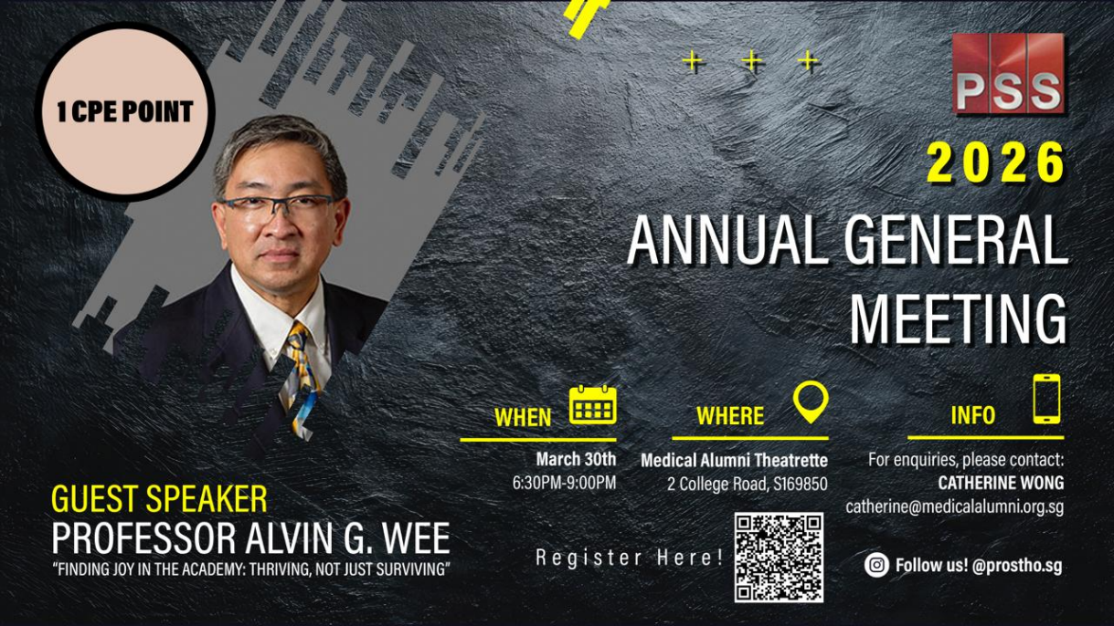
On March 30th, Dr. Alvin Wee gave a presentation at the Prosthodontic Society of Singapore, Singapore. The presentation was titled "Finding Joy in the Academy: Thriving, Not Just Surviving.”
Announcement for Dr. Wee’s Singapore presentation

Spreading the UW Name Around the World …continued

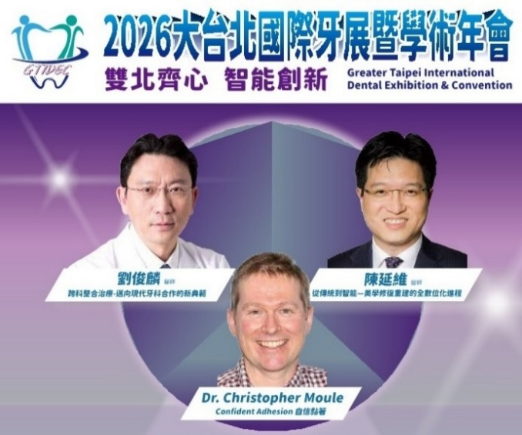

Dr. Yen-Wei Chen was invited as a keynote speaker at the Greater International Taipei Dental Convention on March 14, 2026.

Announcement for Dr. Chen’s presentation

Dr. John Sorenson was invited to lecture for the American Equilibration Society on February 19, 2026 in Chicago, Illinois. This presentation was titled New Frontiers In Digital Prosthodontics: Integrating Digital Materials, Digital Technology and Traditional Prosthodontic Principles Into Clinical Practice.

On February 21, 2026, he presented at LAB Day, the Lab Management Today annual session, also in Chicago. The presentation was titled Advanced Implant Surgical-Prosthodontics Enabled by Innovative Materials & Digital Technologies. From Treatment Planning to Delivery of Zirconia Prostheses.

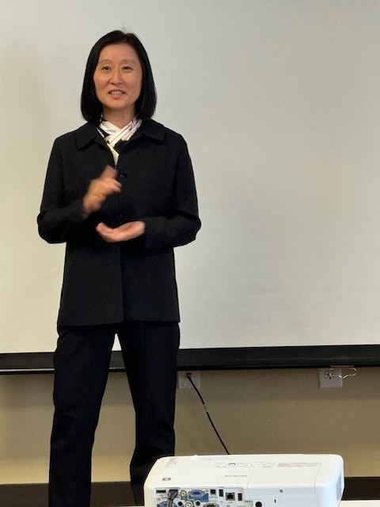
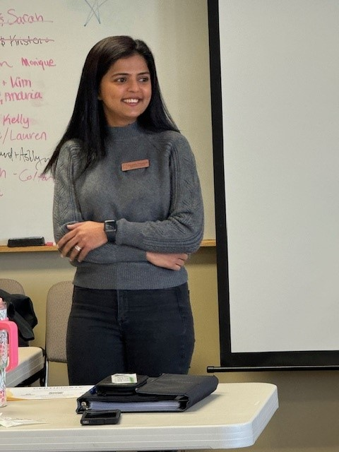

Dr. Amy Kim was invited to speak to Montana State University's AHEC program on interprofessional practice for oral health care on March 6th. This is an annual event put on as part of a HRSA grant.

Dr. Kim presenting at the 2025 AHEC program
Priyanka Prajapati presenting
at the 2025 AHEC program

Congratulations!

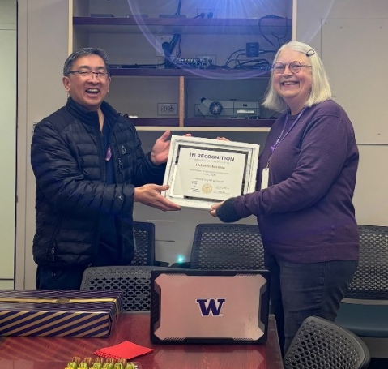
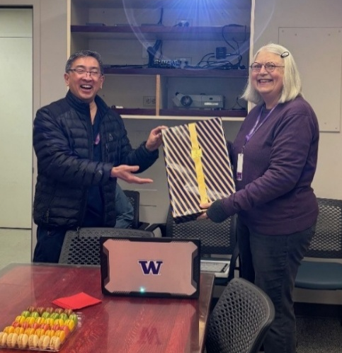
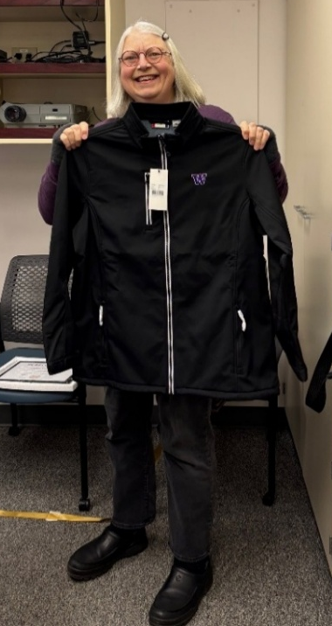
On March 3rd, 2026, a party was held in recognition of Helen Valentine’s 35 years of service. This accomplishment was celebrated with snacks, gifts, and a certificate of achievement. We are so grateful for everything Helen has done in her role here in the Department of Restorative Dentistry.
Dr. Wee handing Helen a gift
Helen displaying her new UW jacket
Dr. Wee handing Helen her certificate
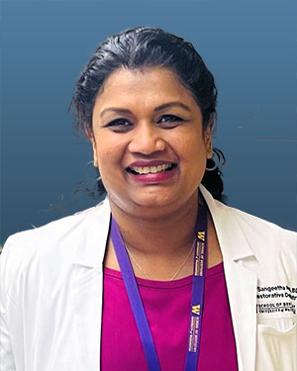

Dr. Sangeetha Nedunchezhian has received the title of Seattle RIDE Clinical Director to recognize her contribution to the RIDE educational process, particularly as she has taken on the role of group leader for the RIDE students while they are on the Seattle SOD campus. Dr. Ned looks forward to continuing to contribute to both the school and the RIDE community.
Dr. Nedunchezhian
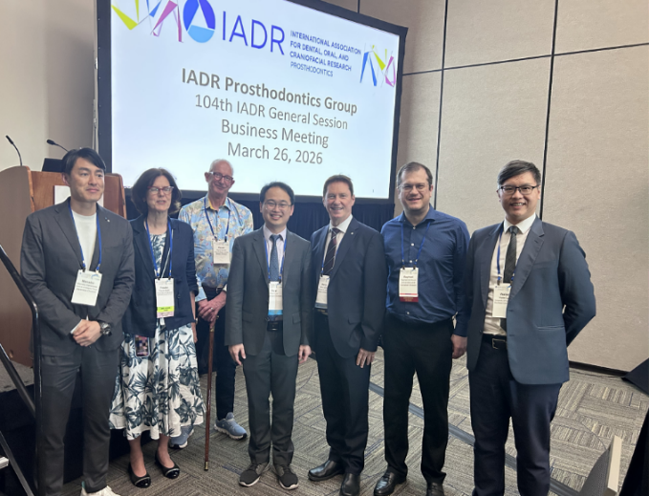
Dr. Liao (4th from left) and attendees of the IADR meeting

Dr. Peixi Liao (Affiliate Associate Professor, Department of Restorative Dentistry) was installed as President of the IADR Prosthodontic Group on March 26, at the IADR annual meeting held in San Diego, CA, from March 25 to 28, 2026. Congratulations,
Dr. Liao!

Congratulations! ...continued

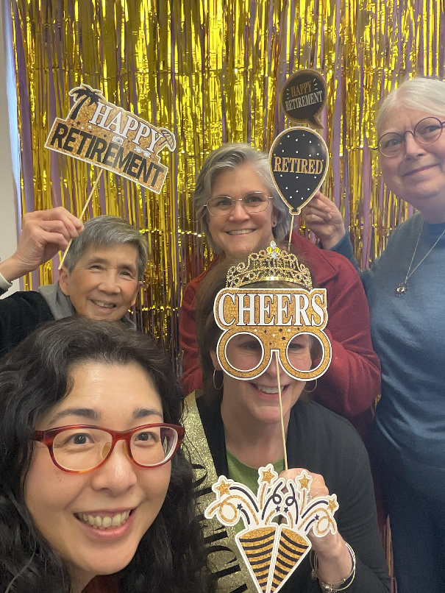
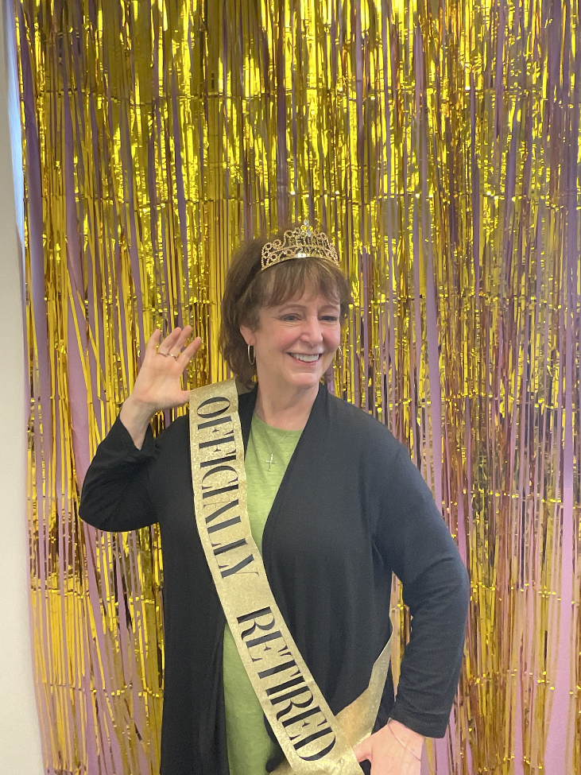
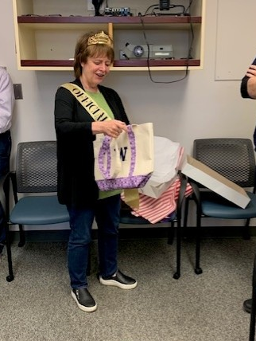
The department hosted a retirement celebration on April 23, marking Robyn Smidley’s final day of service. The event included gifts, refreshments, and a lively photo booth complete with festive decorations and props. Faculty and staff gathered to offer their best wishes, and Dr. Schwedhelm, our Department Vice Chair, expressed heartfelt appreciation for Robyn’s many years of dedicated service to both the department and the University. All photo booth photos can be found in the Robyn's Retirement Party folder on the department's SharePoint site - be sure to check them out!

Robyn and Rest. Dent. staff at the party
Robyn showing off her retirement sash
Robyn opening a gift

Research Collaboration
  - Between the UW Department of Restorative Dentistry
and Badr University in Cairo (BUC)

Dr. Alvin Wee and Dr. Tamer Hamza are developing a research collaboration between our two institutions. Dr. Hamza, a prosthodontist and the current Dean of the Faculty of Dentistry at BUC, has known Dr. Wee for over 20 years. Throughout their longstanding professional relationship, they have worked together on various research projects and visited each other’s institutions.
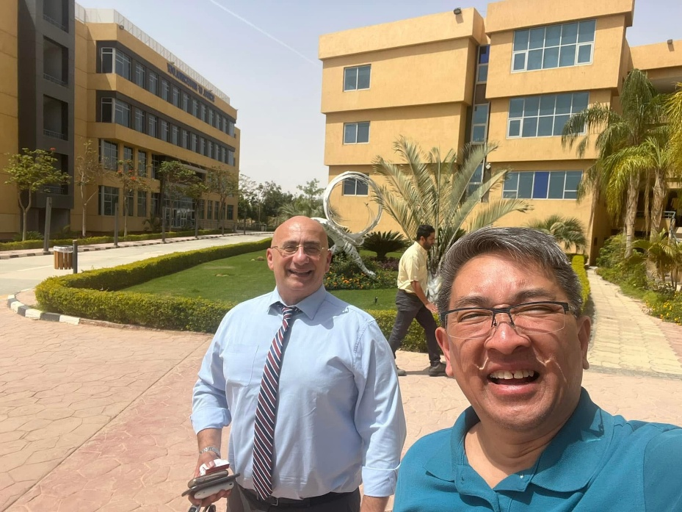
Drs. Hamza (left) & Wee (right) at BUC in Egypt in 2023
Recently, Drs. Alvin Wee and Tammer Hamza have held multiple meetings with Dr. Ana Lucia Seminario, Director of the Timothy A. DeRouen Center for Global Oral Health at the University of Washington, to establish the framework for this new collaboration. The initial phase will include several research projects in which UW Department of Restorative Dentistry faculty members will participate as co-investigators for the master’s theses of BUC prosthodontic residents.

These proposed projects include:

- Comparing conventional and virtual articulation (Dr. James Newman).
- Comparing conventional & digital centric relation recording (Dr. Kavita Shor).
- Comparing CAD/CAM and 3D-printed hybrid ceramics in terms of color stability and biofilm adhesion (Dr. Alvin Wee).
- Comparing different 3D printing machines – dental and non-dental – in terms of vertical marginal fit (Dr. Jean Peng).

This partnership aims to strengthen global research ties and encourage greater involvement of our non-intensive research faculty in collaborative research initiatives.

Thank You, Donors!
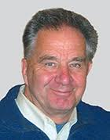
The Department of Restorative Dentistry has received many donations over the past year (Jan to Dec 2025), and we are so grateful to have such a supportive community. Thank you to each and every one of our donors, we truly appreciate your substantial support and involvement in our department. We would not be able to do what we do without your generous gift.
-Dr. Anderson – Department Endowment Officer

Gerald Stibbs Endowed Fund in Restorative Dentistry
- J. Martin Anderson & Lynn Gabriel
- Kenza Houki
- Robert & Judith Allen
- Suzanne Wohlford
- Thomas & Doreen Ramage Jr.

Richard V. and Elaine Tucker Endowed Fund for Faculty Development in Restorative Dentistry
- Robert & Judith Allen
- Timothy & Lisa Hess

Dr. J M Anderson Academy of Operative Dentistry Student Travel Fund
- Bertha J Schumacher Trust
- J. Martin Anderson & Lynn Gabriel
- John & Michelle Yae
- Timothy & Lisa Hess
- Tucker Family Foundation

Non-Cash Gifts - Restorative Dent Fund
- Donna Quinby
- Nobel Biocare USA, Inc.
- Straumann USA

UW Graduate Prosthodontics Alumni Association Endowed Fund
- Alan Sutton
- Warren Libman

Dr. Marty Anderson

Tucker Gift Fund
- Brian Sato & Kimie Hirabayashi

Chair's Fund for Excellence in Restorative Dentistry
- Betty & Loh-Lee Low
- Christine Tran
- David & Joanne Rudo
- E. Ricardo Schwedhelm
- Glen & Susan Johnson
- Ivoclar Vivadent, Inc.
- James & Barbara Newman Jr.
- Jennifer Emerson
- J. Martin Anderson & Lynn Gabriel
- John & Michelle Yae
- Kavita Chigurupati & Alexander Shor
- Mazie Yu & Raymond Park
- Nakanishi Dental Laboratory, Inc.
- Pollene Speed-McIntyre & George McIntyre
- Richard Tucker
- Robert & Judith Allen
- Roy Carlson
- Sami Dogan
- Sandra Anderson
- Sarah Bagoury
- Susanne Jeffrey
- Theresa Malam
- Alvin Wee

Publications / Abstracts

- Wadhwani CPK, Hess D, O'Brien R, Chung KH. Effect of adding a peak marker device to an implant cantilever beam torque wrench on torque value measurement. J Prosthet Dent. 2025;134(6):2425.e1-2425.e5. doi: 10.1016/j.prosdent.2025.08.012. Epub 2025 Sep 1. PMID: 40897558

- Han Z, Xu Y, Xu T, Wang C, Wei Y, Hu W, Chung KH, Liu Y. Changes of Keratinized Mucosa Width Around Posterior Implants: A Retrospective Cohort Study. Int J Dent. 2026 Apr 24;2026:5801279. doi: 10.1155/ijod/5801279. PMID: 42039332; PMCID: PMC1310858

- Sears LM, Koseoglu M, Antonopoulou S, Lee SKY, Kase M, Colebeck A, Lin YC, Huber H, Krzesinski M, Wee AG, Sukotjo C: Assessing the Ability of Large Language Models to Summarize and Generate Maxillofacial Prosthetic Treatment Options. Journal of Prosthodontics – Accepted.

Happy Birthday!

Dr. Marty Anderson Adilene Cordero Helen Valentine
March March April


Jennifer Henry Shayan Niaki
April April

We wish you a happy birthday, and hope your day was wonderful!
If you would like your birthday included in the newsletter, send the
month to Apollo.

Editor: Dr. Alvin G. Wee.​
Design & Layout Editing: Apollo Russon. ​
Copy Editing: Chris Toney.

