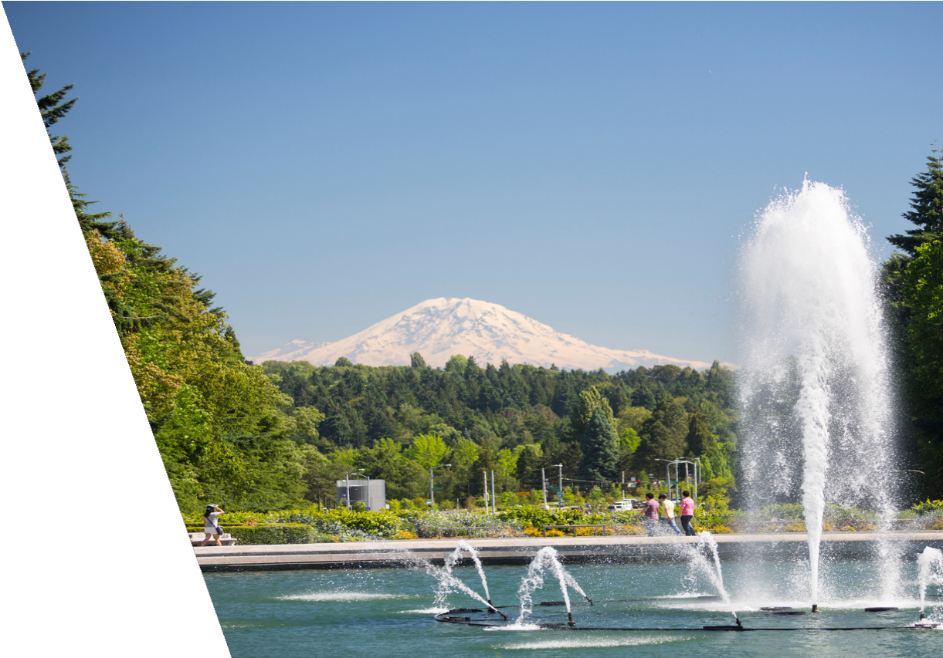
GRADUATE PROSTHODONTICS PROGRAM

NEWSLETTER

2025

Presented by
Graduate Prosthodontics Program

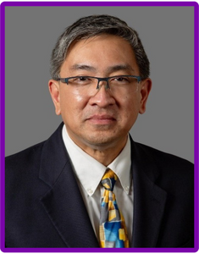
MESSAGE FROM RESTORATIVE DEPARTMENT CHAIR

Dear Colleagues,

We continue to maintain a strong Graduate Prosthodontic Program, and, as expected, the program received extremely positive feedback during our evaluation by the UW Graduate School in January of 2025. This decennial review confirmed the program’s good standing, consistent with the CODA (Commission on Dental Accreditation) site visit at the end of 2024, which resulted in no recommendations.

Our residents continue to make a national impact. In 2025, they took the annual American College of Prosthodontists National Prosthodontic Resident Examination and our program ranked 1st out of 49 programs nationwide. Dr. Mevadee Pibulniyom (UW Grad Pros 2025) presented a poster entitled “Stability of Angulated Multi-Unit Abutments in Implant-Supported Fixed Dental Prostheses” at the 2025 Pacific Coast Society for Prosthodontics, where she was awarded 1st place in the Graduate Prosthodontics Research Competition and received the Han Scoble Memorial Scholarship Award for exceptional prosthodontic treatment and patient care.
We were saddened by the passing of our revered, long-time faculty member, Emeritus Professor Jack Nicholls, on July 2, 2025, at the age of 93. Jack retired at the end of 2004 after a 31-year tenure at the School of Dentistry, during which he applied biomechanical engineering principles to address prosthodontic clinical questions. He was an outstanding research mentor to both faculty and graduate students and was beloved by all who worked with him.
The program continues to evolve and change. Carole Green, Prosthodontic Clinic Manager, retired on November 14 after 21 years of dedicated service. Furthermore, Dr. Alan Sutton, who succeeded Dr. Jeffrey Rubenstein as Director of Maxillofacial Prosthetic Services in October 2021, retired on January 5, 2026. On a very positive note, Dr. Van Ramos has been elected as the newest examiner for the American Board of Prosthodontics, a testament to his professional standing and contributions to the specialty.

Thank you all for your ongoing support of our residents, staff, and faculty, and for your continued commitment to the success and reputation of our Graduate Prosthodontic Program.

Alvin G. Wee, DDS, PhD, MPH Professor and Chair

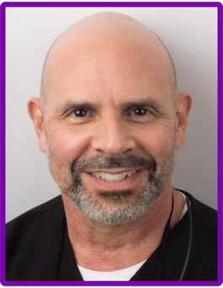
MESSAGE FROM PROGRAM DIRECTOR

Hello again to everyone, and thanks for reading this update. It has been another great year of learning and patient treatment for the residents. We had one resident graduate earlier this year in June. I want to thank those of you who were able to attend. It is always great for the residents to interact with alumni so they can see that there actually is life after residency training. This year, the graduate was Mevadee (May) Pibulniyom. After graduation, she worked in a private practice not far from Seattle, but she decided she wanted more education. She applied for and was accepted at the Implant Fellowship at Loma Linda where she will start this coming summer. She, along with all four of the 2024 graduates (Amr Abouzeid, Marco Bergamini, Marwan Fattouhi, and Seoyoun Hahn), also became board-certified at the ABP oral exams/case presentations in October. That means that every graduate from 2022-2025 has become board-certified. There are no real criteria to “rank” residency programs like college football teams, however if there were a ranking system, the percentage of graduates who become board-certified would certainly factor into it.
On the Friday following graduation, we had the Ralph Yuodelis Lectureship for which Keith Phillips was our honored speaker. He drew a large crowd and helped us raise a significant amount of money for the program.

Although 2025 was a great year for learning, we also had some unfortunate departures from the program. Dr. Hai Zhang left the SOD to become department chair and program director at the University of Texas in San Antonio. Dr. Alan Sutton announced his retirement, effective January 2026, and Carole Green retired in November. We certainly will miss them.

Recap of the Year

One of the nicest things about the start of 2025 was that we were finished with the CODA site visit. We still, however, had one more site visit scheduled. This was from the UW Graduate School so they could evaluate our Master’s Program. Fortunately, this also went well.

MESSAGE FROM PROGRAM DIRECTOR

-CONTINUED-

The David H. Wands Luncheon was held in the 2nd week of February to recognize the new Wands Fellowship awardee, Dr. Shayan Niaki. As usual, it was a great occasion. Then later in February, the residents and I attended the American Academy of Fixed Prosthodontics meeting in Chicago. At this meeting, I received The Moulton Award, which recognizes members who have made a significant impact and contribution to the art and science of fixed prosthodontics and have demonstrated lifetime service to the field. This prestigious award is the highest honor bestowed by the Academy. I was very happy to have the residents in attendance when the award was presented. Later that night, we attended the alumni dinner organized by Mike Waliszewski at Joe's Seafood, Prime Steak, and Stone Crab. It was a splendid event, and my thanks goes out to Mike for all his efforts in arranging the dinner, but also for spearheading the Grad Pros Alumni Endowment. I use the proceeds from that account to fund resident travel to meetings like this. At the end of the month, Dr. Chandur Wadhwani came to give the residents a lecture presentation. He also gave another presentation later in the summer quarter.
In March, Dr. Mike Waliszewski came to lecture on RPDs. This was a 2-part presentation; he gave the 2nd part in November. In April, the 3rd year residents and I were invited by the WSSO for dinner and a lecture presentation.

In June, soon after graduation, the academic year began with 3 new residents. They are Jill Grant (USA), Remi Huh (Canada), and Lujain Shelbayh (Jordan). The summer quarter was fairly uneventful; however, the end of that quarter is always marked by the 2-day interview process for 2026 starts. This was the first year where candidates did not have to prepare teeth on typodont/manikins due to the renovation that was going on in the D-1 Simulation Lab. I hope to bring it back for next year.
In the fall quarter, the residents and I attended the ACP Annual Session in New Orleans. I was the Program Chair for the Scientific Session this year, so it was nice to have the residents in attendance. It was also good to see many of the alumni in attendance. Soon after this meeting, at the end of November, the ACP announced that I had been elected as the Director-Elect (Board Examiner) for the American Board of Prosthodontics. Then later in November, Dr.’s Yoshi Goto and Alex Shor gave an afternoon presentation to the residents.
I want to thank all our alumni for supporting us, and I want to particularly thank those who were able to come see us in person or make a specific contribution: Armand Bedrossian, Yen-Wei Chen, Will Chung, Marwan Fattouhi, Yoshi Goto, Bree Hsu, Jae Seon Kim, Warren Libman, Joshua Manchester, Tal Mor, Jean Peng, Keith Phillips, Alex Shor, Chandur Wadhwani, Michael Waliszewski, and Dave Wands.

Van Ramos, Jr. DDS, FACP
Program Director, Graduate Prosthodontics vanramos@uw.edu

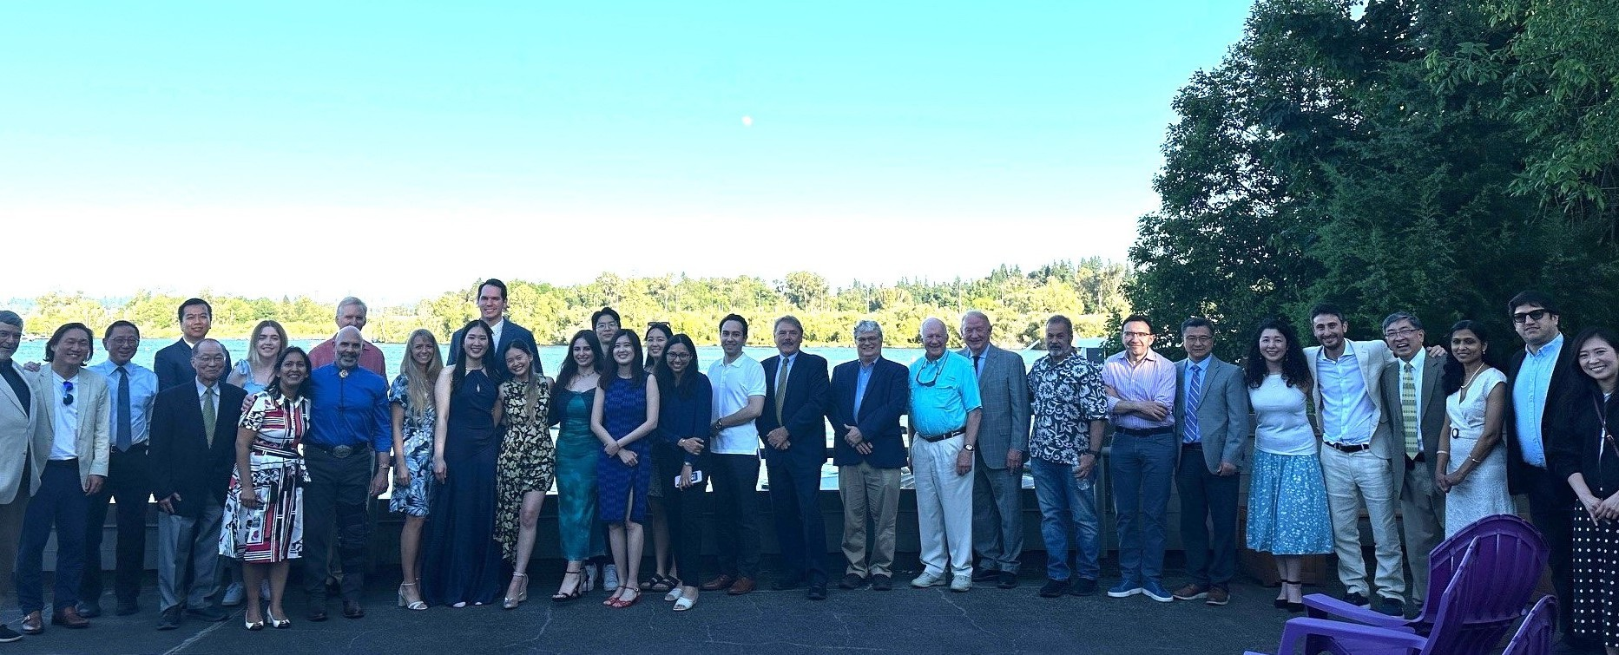
GRADUATION 2025

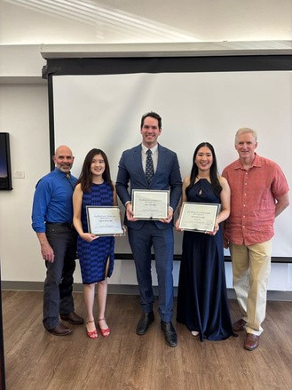
On June 7, we celebrated a special mile stone for three of our residents, Drs. Esther Yi Ting Chen, Ludovic de Carle and Mevadee Pibulniyom.
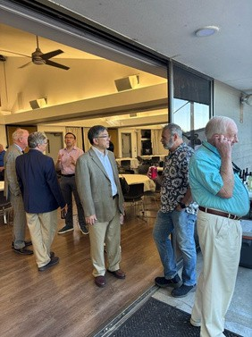
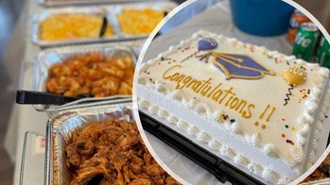
We would like to thank people who donated to support the event. This year’s graduation ceremony was sponsored in part by Drs. Will Eunku Chung, Warren Libman, Jeffrey Rubenstein, and Kois Center, LLC, and Shor Dental.

Photos provided by the Grad Pros newsletter team.

4th Year Students

CURRENT STUDENTS

Dr. Esther Yi Ting Chen earned her DDS from Chung Shan University (Taiwan) Dr. Ludovic de Carle earned his DDS from New York University
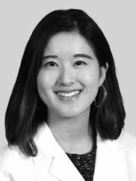
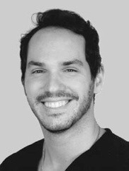
Esther Ludovic

3rd Year Students

Dr. Sarah Haddad earned her DDS from University of Jordan (Jordan)
Dr. Trisawan Limmaneevichitr earned her DDS from Mahidol University (Thailand) Dr. Shayan Niaki earned his DDS from New York University
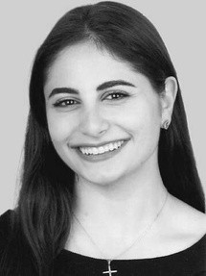
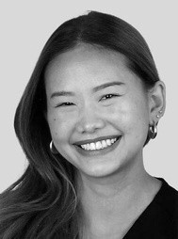
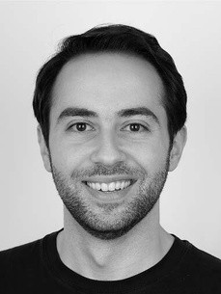
Sarah Trisawan Shayan

2nd Year Students
CURRENT STUDENTS
-CONTINUED-

Dr. Nivedita Chinam earned her BDS from Goa Dental College and Hospital (India) Dr. Jayden Park earned his DMD from University of Manitoba (Canada)
Dr. Cindy Robillard earned her DMD from McGill University (Canada)

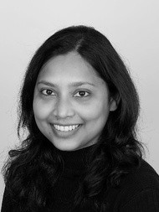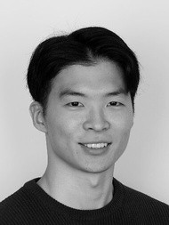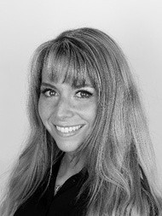

Nivedita

1st Year Students
Jayden Cindy

Dr. Jillian Grant earned her DDS from Touro College of Dental Medicine at New York Medical College Dr. Remi Huh earned his DDS from University of Toronto (Canada)
Dr. Lujain Shelbayh earned her BDS from Jordan University of Science and Technology (Jordan)

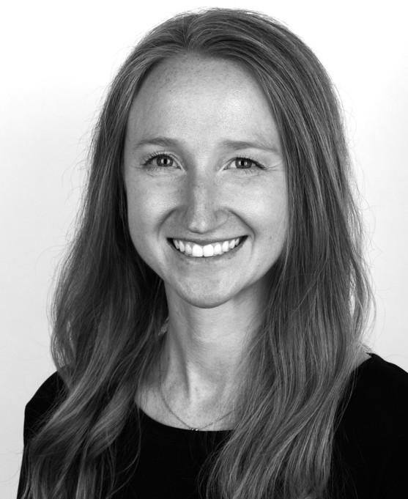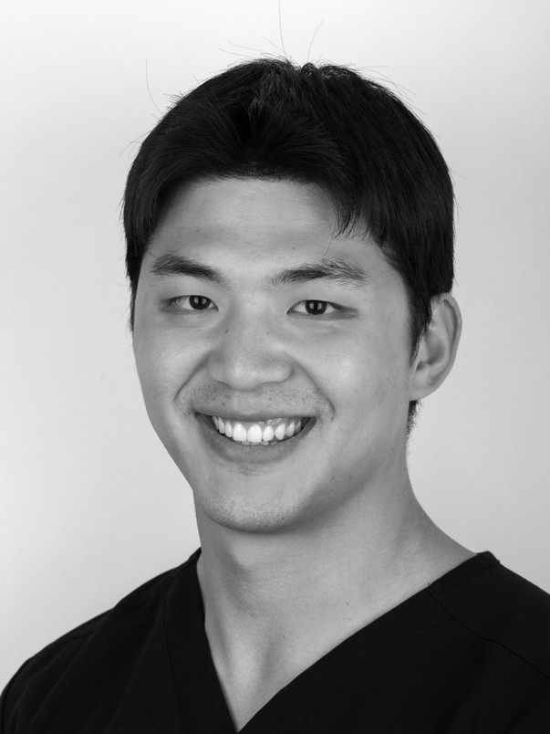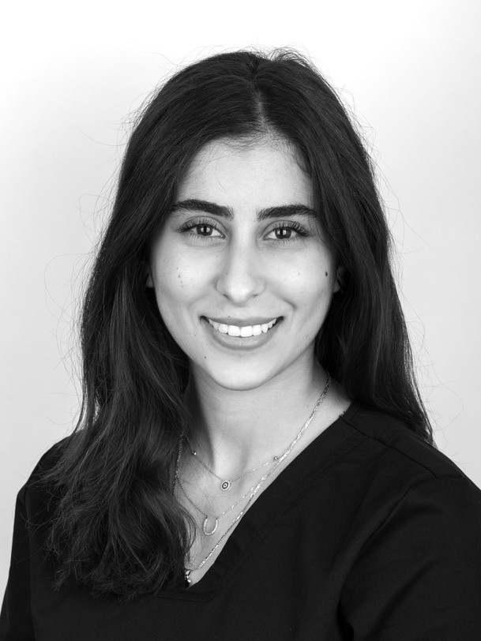

Jillian
Remi
Lujain

STUDENT HIGHLIGHTS

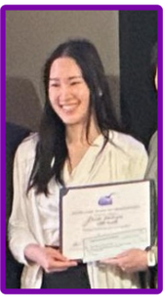
Student Awards
Dr. Mevadee Pibulniyom received the Han Scoble Memorial Scholarship Award in recognition of her outstanding prosthodontic treatment and patient care.
Additionally, she earned 1st place in the Graduate

Prosthodontics Research Competition at the Pacific Coast Society for Prosthodontics. Her research, titled “The Influence of Multi-Unit Abutment Angulation on Implant-Supported Fixed Dental Prosthesis Stability,” was highly regarded.

Student Research Grants

Award Presentation
Photo provided by the department newsletter team.

- Dr. Ludovic de Carle received a research gift from Ivoclar to support his MSD research project.
- Dr. Shayan Niaki received a research gift from Ivoclar to support his MSD research project.
- Dr. Jayden Park received the prestigious American College of Prosthodontists Education Foundation Research Fellowship Grant. The $5,851 grant will fund his MSD thesis research: Evaluation of trueness of complete dentures fabricated by additive and subtractive manufacturing systems and incorporation of stabilization features. Dr. John A. Sorensen is his mentor for this grant and his MSD thesis research.

Meeting and Symposium
Vico (Ludovic), Esther, Sarah, Tris (Trisawan), and Shayan attended the Washington State Society of Prosthodontists meeting in April.

Sarah attended the Straumann Resident Symposium in Boston in June where she was treated to lecture presentations and a tour of their manufacturing facility.

By Dr. Van Ramos, Jr.

STUDENT HIGHLIGHTS

-CONTINUED-

Student MSD Research Projects

- Dr. Esther Yi Ting Chen: Effects of Airborne-Particle Abrasion on Surface
Roughness, Bond Strength, and Flexural Strength of Zirconia Materials (Dr. Kwok-Hung Chung)

- Dr. Ludovic de Carle: Effect of Various Mandibular Incisor Tooth
Preparation Designs and Remaining Tooth Structure Dimensions on Resistance to Fatigue Loading (Dr. John Sorensen)

- Dr. Sarah Haddad: The Use of a Diode Dental Laser to Break Down a
Novel Resin Cement (Dr. Kwok-Hung Chung)

- Dr. Trisawan Limmaneevichitr: Comparison of Retentive Strength Between
Conventional Cements and a Laser-Activated Experimental Cement for Fixed Prosthodontic Applications (Dr. Daniel Chan)

- Dr. Shayan Niaki: Crown Margin Fidelity and Damage Induction from
Novel Manufacturing Technologies, Innovative Materials & Rapid Processing Protocols
(Dr. John Sorensen)

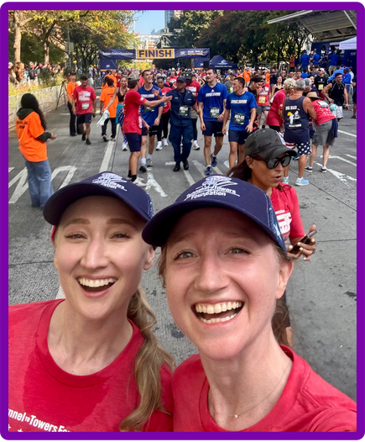
Community Engagement
Jill Grant, 1st year Grad Pros students, and her family completed the 24th annual Tunnel to Towers 5k run on September 28. This is a run to honor the 1st responders on 9/11.

By Dr. Van Ramos Jr.

Jillian and Her Sister
Photo courtesy of Jillian Grant

PROGRAM NEWS

Prosthodontic MSD Review

The UWSOD hosted an Academic Program Review administered by the UW Graduate
School on January 23rd and 24th. The review committee included two faculty members from UW and two external site visitors from OHSU and USC. UW Graduate School representatives also participated in some of the meetings. This review and site visit occur approximately every 10 years. The Prosthodontic MSD program was one of the 9 programs that were reviewed. The Dean received a verbal report from the review committee at the exit discussion on January 24th the feedback was extremely positive. Congratulations to Dr. Van Ramos and his team.
By Dr. Alvin Wee, Department Newsletter

National Prosthodontic Resident Exam

Every year, the American College of Prosthodontists administers a 150-question written exam called the National Prosthodontic Resident Exam. The goal of the exam is to give program directors an idea of how their residents rank compared to other residents around the country and to assist in preparing residents to take the written exam (Section A) of the American Board of Prosthodontics. Residents must successfully pass this exam to continue on to the next three sections for board certification. In 2025, our graduate prosthodontic program ranked 1st out of the 49 programs around the country. Additionally, five of our residents ranked in the top ten in the nation!
By Dr. Van Ramos, Jr., Department Newsletter

Board Certification

Drs. Dana Buglione, Amr Abouzeid, Marco Bergamini, Marwan Fattouhi and Seoyoun Hahn have become a board-certified prosthodontist. Please join us in congratulating them on this outstanding achievement. Dr. Mevadee Pibulniyom passed part 4 of the Section B exam.

PROGRAM NEWS

-CONTINUED-

On September 11 and 12, there was a new student interview for Grad pros Program.

Although we were unable to hold the tooth preparation exam due to the remodeling of the D-1 simulation lab, we still had a rich and rewarding selection process, including a written
exam, a wax-up exam, and formal interviews with the selection committee. The 3rd year
residents introduced the program during the reception. Three new students will be joining the program in June 2026.

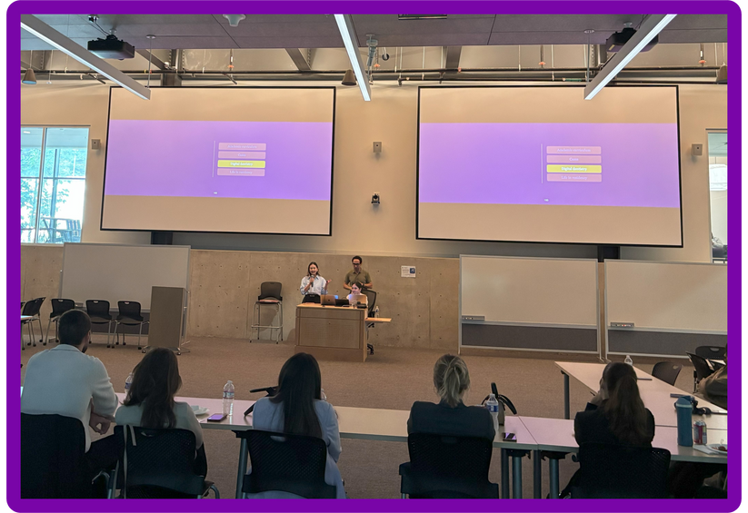
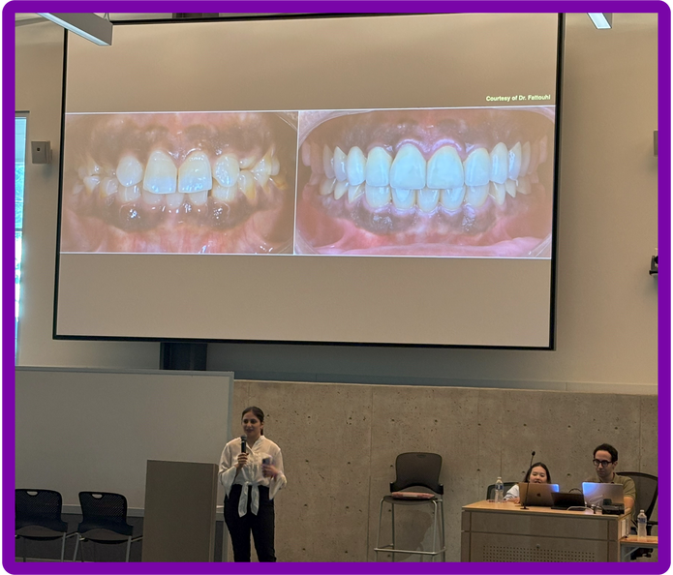
The 3rd year residents presented the program.

Photos provided by the Grad Pros newsletter team.

Thank you for your contributions to our program.
FAREWELL TO DEPARTING FACULTY AND STAFF

This year, we have said goodbye to some of our valued colleagues. They are Dr. Alan Sutton, Dr. Hai Zhang, and Carole Green.

While we miss them deeply, we are incredibly grateful for the time we had working with them, getting to know them, and sharing wonderful experiences together. Those memories are truly priceless. The good news is that Dr. Sutton and Dr. Zhang will remain engaged as affiliate faculty.

We invite you to join us in wishing them all the best as they begin the next chapter of their journey.

Dr. Alan Sutton

Dear Colleagues,

As I prepare to retire after more than 40 years of committing my life to dentistry and teaching, I want to take a moment to express my heartfelt gratitude to each of you. These past four years at the University of Washington have been incredibly meaningful, both professionally and personally. Teaching our awesome residents and working alongside such dedicated professors and support staff has been a privilege I will always cherish.

I’ve learned so much from our shared experiences, and I’m proud of what we’ve accomplished together. Whether in the classroom, clinic, or after-hours study clubs, your interest, attention, support and camaraderie have made my journey truly rewarding. Many of our residents have achieved the pinnacle goal of getting their board! This is truly a reflection of Dr. Ramos’ outstanding graduate prosthodontic program and his commitment to each resident he teaches.

While I’m looking forward to the next chapter, I will deeply miss the daily interactions, the laughter, and the sense of purpose that comes from being part of this department. I leave with fond memories and great respect for the work you do and all you give every day to make the future in dentistry and prosthodontics bright!
FAREWELL TO DEPARTING FACULTY AND STAFF
-CONTINUED-

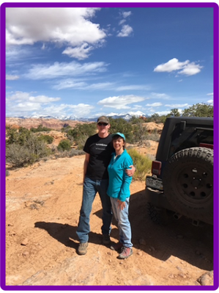
Wishing everyone all the very best in your future endeavors.

Warm regards,

Alan

Alan J Sutton, DDS, MS
Associate Professor & Director Maxillofacial Prosthetics Service Assistant Program Director, Graduate Prosthodontics
Board Certified Prosthodontist/Maxillofacial Prosthodontist University of Washington School of Dentistry
Department of Restorative Dentistry

Photo courtesy of Dr. Sutton

Dr. Sutton was born to be a prosthodontist and a teacher. I could not have asked for a more capable and motivating colleague in all my years of teaching. His dedication to the program and the residents is admirable. His “superpower” is to impart knowledge and to produce clinicians who excel in the application of prosthetic dentistry, from reading the literature, learning and developing laboratory skills, and performing clinical treatments, for the betterment of patient’s oral health. I applaud him for motivating residents to go beyond what is expected, and to really think about how their performance and achievements in the program shape and affect their future. He has brought this program to new heights through his knowledge and experience, and his contributions of weekend seminars, evening study club lectures, and always being available for the advancement of education. It was very satisfying and reassuring to me just knowing that he was available to help beyond his everyday teaching. This was especially true when we had student observers come to the program as he could “wow” them with all the treatments a maxillofacial prosthodontist could perform. I know that a significant number of applicants applied to our program specifically because of the maxillofacial prosthetics they could learn as a resident in this program.
FAREWELL TO DEPARTING FACULTY AND STAFF
-CONTINUED-
It is unfortunate for the program to lose such a stalwart in the field, but his reputation and contributions will remain in the teaching and training philosophy of our program. I thank him for being a friend to me and to our advanced education program in prosthodontics and wish him good luck in the future.

Dr. Van Ramos, Jr.
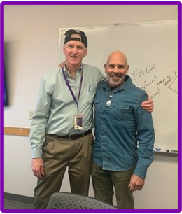
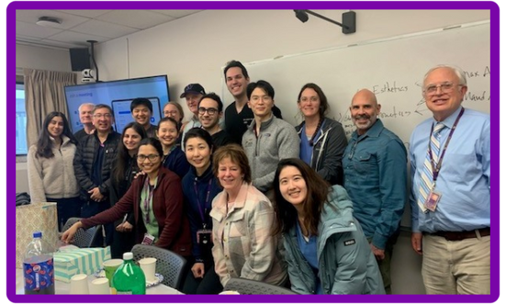

Photo courtesy of Betty Low

Dr. Hai Zhang
FAREWELL TO DEPARTING FACULTY AND STAFF
-CONTINUED-

When I first arrived at the tail end of 2016, it was Dr. Zhang who had been holding the program together for the previous five plus years. It was just the month before I arrived that he navigated the program through a CODA site visit. At the same time, he still had pre-doctoral teaching responsibilities and his ongoing research, for which he has numerous publications and for which he is known nationally and internationally. After I took over as program director, Dr. Zhang continued to be a big part of the program through his teaching of formal courses in research, occlusion, and removable partial dentures, and his work in the clinic attending to residents. In addition to his duties within the program, he also contributed to prosthodontics on the national level. He has chaired research committees for the American Academy of Fixed Prosthodontics and the American College of Prosthodontists, and he has been a positive force for research within the program. I’d like to thank him for all his years of dedication to the program, and to the art and science of prosthodontics. I’m sad to see him go, but I’m happy for him and know he is moving up in the world of academia.

Dr. Van Ramos, Jr.

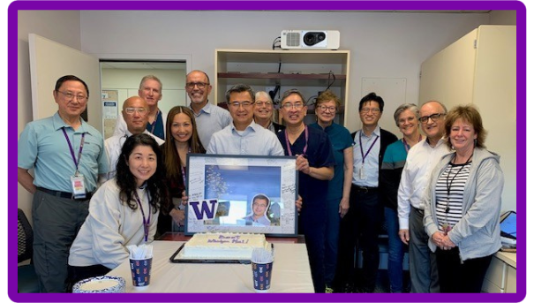
Photo provided by the department newsletter team.

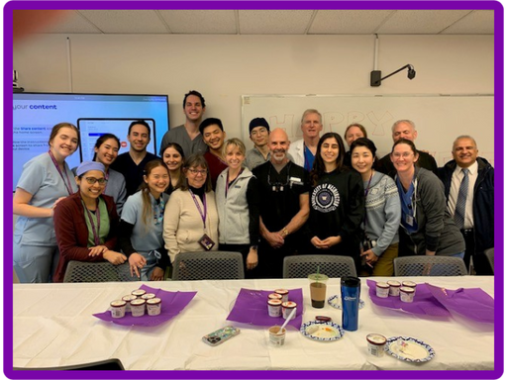
Carole Green
FAREWELL TO DEPARTING FACULTY AND STAFF
-CONTINUED-

Photo courtesy of Betty Low

It did not take me long to figure out that I was very fortunate to have Carole Green here managing the clinic’s finances and operations when I arrived. Carole has been a friend and confidant for the past 9 years. She is the eyes and ears of the program, and one who continuously has her finger on the pulse of the operational and financial environment to keep us running smoothly. She has been here for
21 years, so she knows just about everyone in the building, and she has a remarkable ability to get things done. Her historical knowledge of the program in dealing with patients has been very helpful, since not all patients come with a good recollection of their treatment.

This level of knowledge is irreplaceable. She has such dedication to the program that it is so rare for her to take a sick day or vacation when clinic is in session. I will miss her a lot, but I hope being around family, especially her grandchildren, will bring her much happiness.

Dr. Van Ramos, Jr.

Carole thoughtfully chose November 14, 2025 as her retirement date, marking exactly 21 years since she joined the Graduate Prosthodontic Program at the School of Dentistry. Over the years, she has guided 21 classes of graduate prosthodontic students and has proudly watched many of them become internationally renowned lecturers.
Her management style has always been unassuming, but she leaves no stone unturned. Thanks to her leadership, clinic operations and fiscal management have run like a well-oiled machine. We, patients, staff, faculty, students, will miss her and wish her all the best as she embarks on this exciting new chapter…. Look out, world…she’s just getting started!

Betty Low

FACULTY NEWS

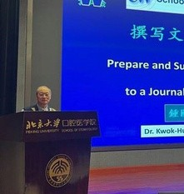
Dr. Kwok-Hung Chung delivered presentations both locally and internationally, including at the UW/Dentway Symposium Collaboration Annual Course, as well as at academic institutions overseas such as Peking University. Notable topics include “Prepare and Submit a Manuscript to a Journal for Publication” and “Biomaterials in Dentistry – Metals and Alloys.”

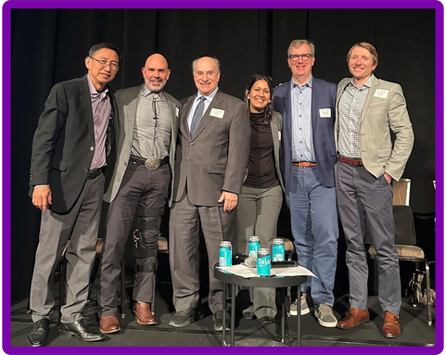
Dr. Van Ramos, Jr. delivered several lectures including at the Operative Academy Meeting in Chicago and the AGD Master Track Seminar. He also chaired the ACP Post-Doctoral Committee Meeting and was featured as a panelist in an interdisciplinary session during the Washington State Society of Orthodontists meeting. Dr. Ramos was recently selected as Director Elect (board examiner) for the American Board of Prosthodontics.
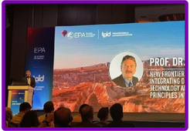
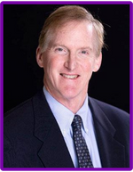
Dr. John Sorensen was conferred Honorary Membership to the International Academy of Adhesive Dentistry and received the Distinguished Researcher Award from the ACP. Throughout the year, he presented 8 invited lectures at national and international conferences, published 4 papers in peer reviewed journals, mentored 4 MSD theses and secured new research funding. For the 15th year Dr. Sorensen was named “Leaders In Continuing Education” in Dentistry Today.

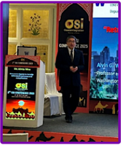
Dr. Alan Sutton delivered multiple lectures in 2025, including two sessions for the South Shore Study Club on occlusion and bruxism. He also presented on maxillary defect restoration at the OMFS Grand Rounds. Most recently, he shared a lecture titled “Speech and Maxillofacial Prosthetics” at the FHCC Oral Cancer Rehabilitation Course.

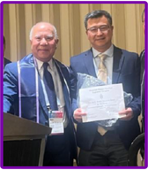
Dr. Alvin Wee was invited to give several lectures in 2025 including at the University of Iowa Prosthodontic Alumni Reunion, HangZhou China, Taipei Taiwan, Singapore, Haarlem Netherlands and Jaipur India. He also attended the AAL Chairs & Academic Administrators Management Program (CAAMP) in Atlanta, a multi-disciplinary workshop focused on academic leadership and departmental management. He was elected to the Board of Directors as the ACP Forum Director at the 2025 ACP annual meeting.

Dr. Hai Zhang contributed to a range of academic, leadership, and service activities, including course leadership, conference participation, and community outreach before transitioning to the University of Texas at San Antonio as the chair of Department of Comprehensive Dentistry and the director of Graduate Prosthodontics program. Notably, at the ADEA Annual Conference, he received the OKU Jon B. Suzuki Research Award.

Photos provided by the department newsletter team.

CONFERENCES

American Academy of Fixed Prosthodontics

February 21 and 22, 2025
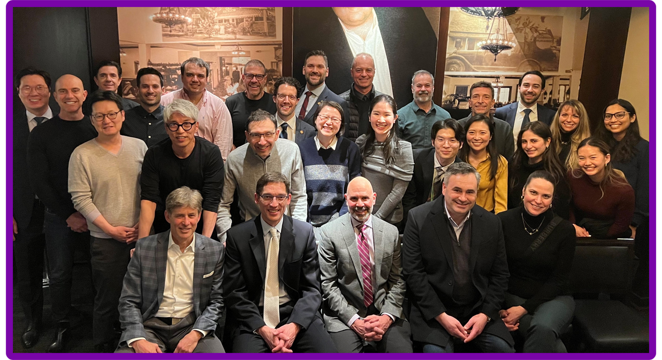
Alumni dinner at the 74thAmerican Academy of Fixed Prosthodontics held in Chicago.

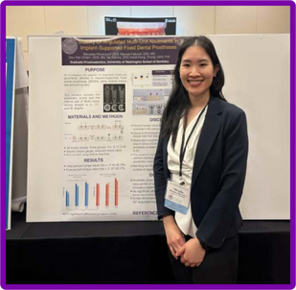
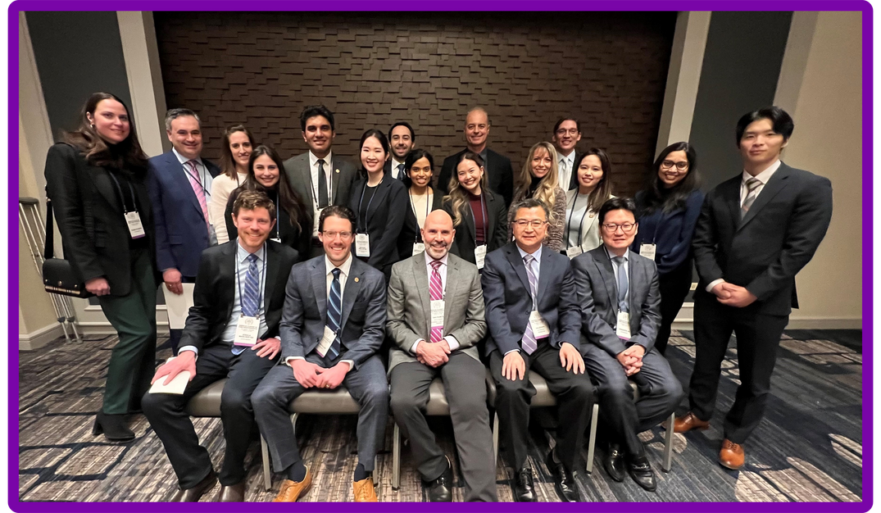
Dr. Mevadee Pibulniyom presented a poster at the Academy of Prosthodontics meeting held in Scottsdale, Arizona, from May 28 to May 31, 2025. Its title was "Stability of Angulated Multi-Unit Abutments in Implant-Supported Fixed Dental Prostheses."

Photos provided by the department and the Grad Pros newsletter team.

CONFERENCES

-CONTINUED-

American College of Prosthodontists

October 22 - 25, 2025

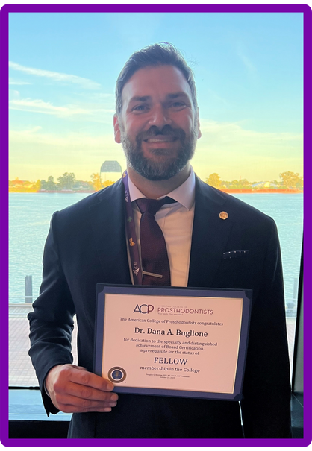
Dr. Dana Buglione received recognition for achieving board-certification from the American Board of Prosthodontics and becoming a Fellow in the American College of Prosthodontists during the 2025 Annual session of the ACP meeting.
By Dr. Van Ramos, Jr.

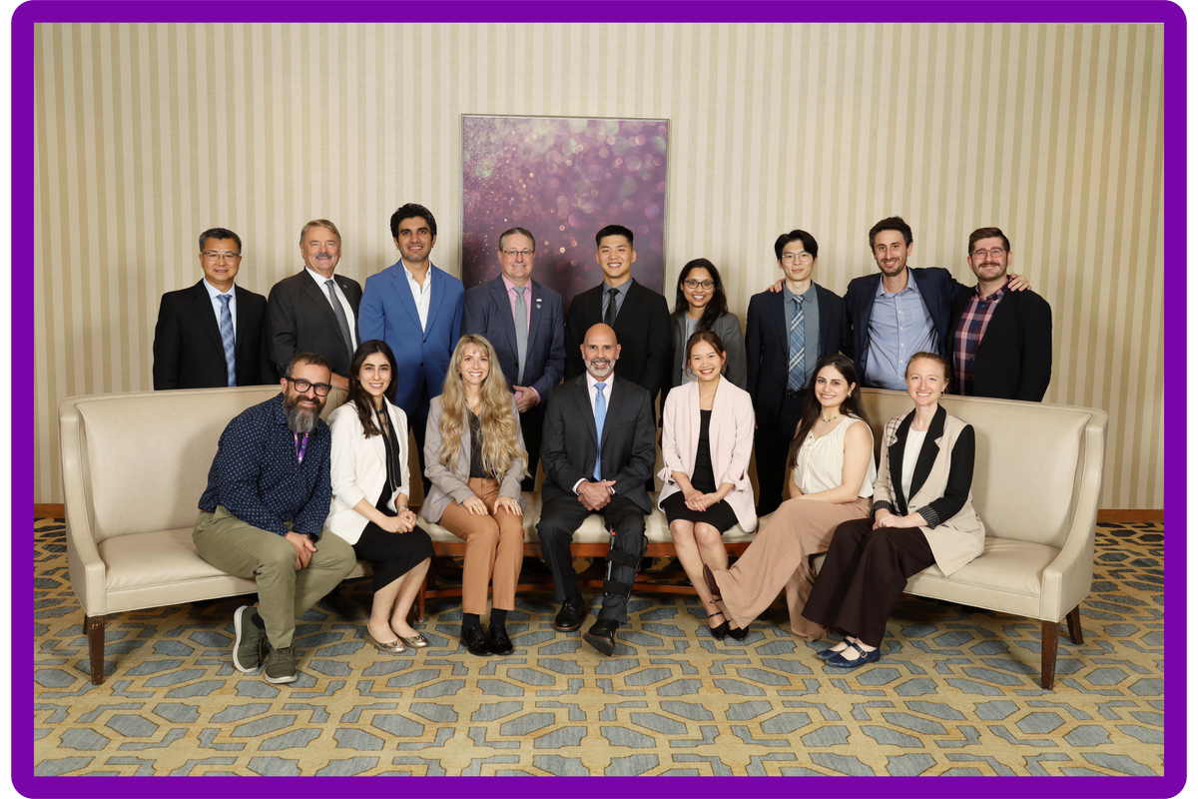

Photos provided by the the Grad Pros newsletter team.

TRAININGS

Digital Training
Dr. Hai Zhang organized a 3DBioCAD event on Saturday, January 18, 2025 from 9 am to 2 pm at the B&B Dental Laboratory. There was a lecture on the update in digital
scanning, as well as four rotation stations:
- printing,
- hands on photogrammetry,
- design for single RPD, and
- 2D digital smile design.

Around 20 faculty and residents attended, and refreshments were provided.

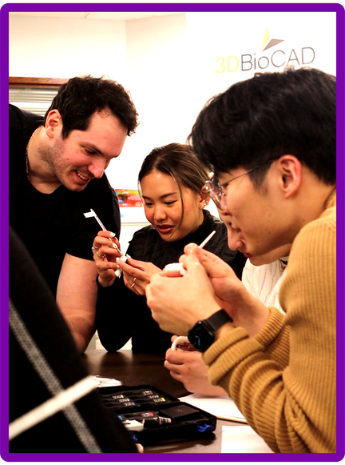
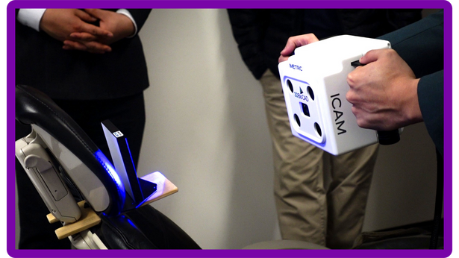
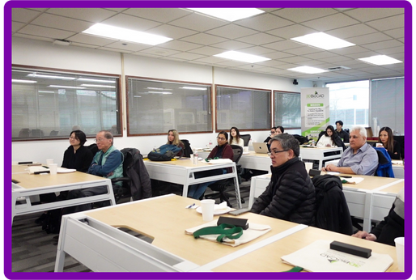
By Dr. Alvin Wee and Apollo Russon, Department Newsletter

Photos provided by the department newsletter team.

GUEST PRESENTATIONS

Many individuals shared their valuable knowledge with residents through presentations in 2025.
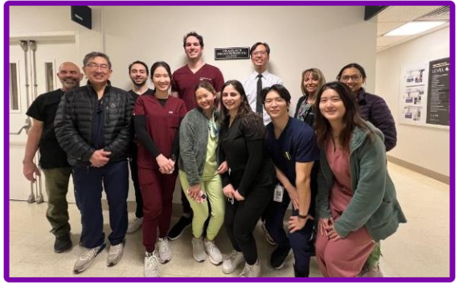
Dr. Khng pictured with Residents and Drs. Ramos and Wee
Photo provided by the department newsletter team.

Dr. Kelvin Khng, BDS, MS, FACP, FAMS, was trained at the University of Iowa’s Graduate Prosthodontic program and is board certified in both the United States and Singapore. He is the owner of his private practice and teaches part-time at National University of Singapore. He spoke to the graduate residency program on “Mandibular Suction-Effective Denture.”
By Dr. Alvin Wee, Department Newsletter

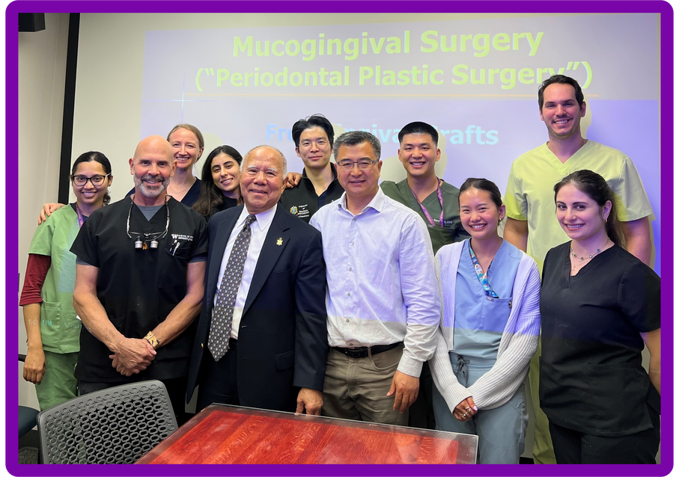
Dr. Jon Suzuki delivered a lecture to the residents on April 11 titled “Non-Surgical and Surgical Therapies for Peri-Implantitis.” He also returned on August 29 to present on “Keratinized Gingiva and Implant Diseases.”

Dr. Suzuki with residents alongside Drs. Ramos and Zhang
Photo courtesy of Dr. Suzuki

DONATION

We are deeply grateful for the generous contributions to the UW Grad Pros Program, including donations to the Alumni Association Endowed Fund and the Wands Fellowship Fund. These gifts help sustain and expand opportunities for our faculty and students, supporting professional development, mentorship, and community-building efforts.


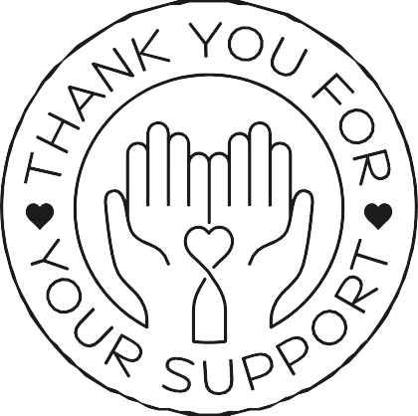

If you’d like to make a difference, we welcome donations of any amount. Your support helps us continue growing a vibrant and impactful Grad Pros community.

Online
Go to SOD's online donation site SOD's online donation site. Search for “UW Graduate Prosthodontics Alumni Association Endowed Fund” in the search box.

By Mail
Make your check payable to “UW Foundation” and send to:
UW School of Dentistry Advancement 1959 NE Pacific St.
Box 357137
Seattle WA 98195-7137
Please write “UW Graduate Prosthodontics Alumni Association Endowed Fund” in the memo line of your check.

By Phone
Please contact SOD Advancement at 206-685-9350.

2025 UW Graduate Prosthodontics Program Newsletter

Editor: Grad Pros Newsletter Team
Email: akikok2@uw.edu
Phone: 206-543-5923

Website:
https://dental.washington.edu/restorative-dentistry/graduate-prosthodontics-program/
Facebook page: please contact Akiko for the access

Special thanks to all contributing authors for contents and to those who provided pictures. If you have any questions or comments, please feel free to contact Dr. Ramos or Akiko.

