
Bi-Monthly Restorative Review
  - Department Newsletter July - August 2026
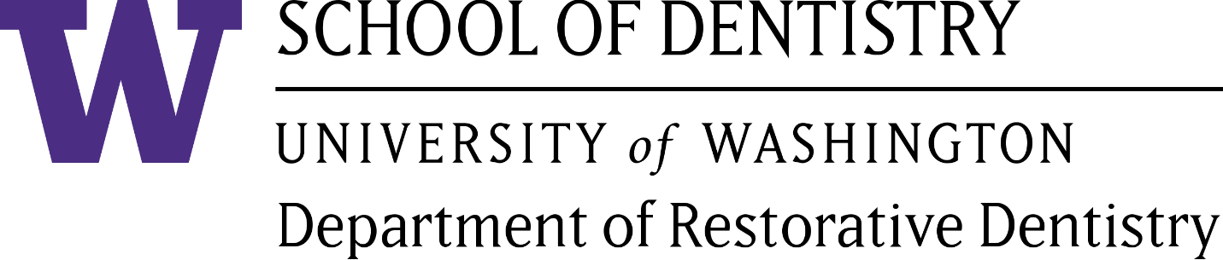


Welcome!

Inaugural Tucker Family Faculty Fellowship

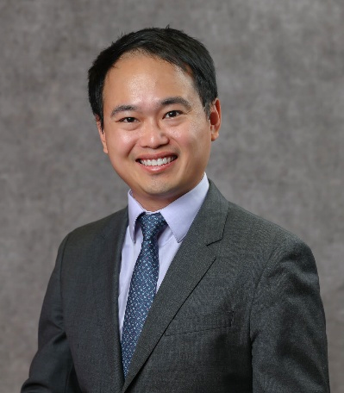
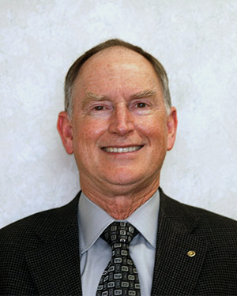
Our department is honored to recognize the generous support of Dr. Richard D. Tucker and his family. Their donation has made possible the establishment of the Tucker Family Faculty Fellowship in Restorative Dentistry.
Dr. Richard Tucker
Dr. Peixi Liao
This fellowship supports an additional paid day each week for teaching and mentoring in our predoctoral dentistry clinics. Eligible affiliate faculty members must volunteer one day per week in the predoctoral D2/D3 clinics. With fellowship support, selected faculty will teach a total of two days per week in our clinics.
I am pleased to announce that Dr. Peixi Liao, a prosthodontist and affiliate associate professor, has been selected as the program’s first Fellow. His term would be from September 2026 to August 2027.
Dr. Alvin Wee, Professor and Chair

Welcome!
Advanced Education in General Dentistry (AEGD) Residents

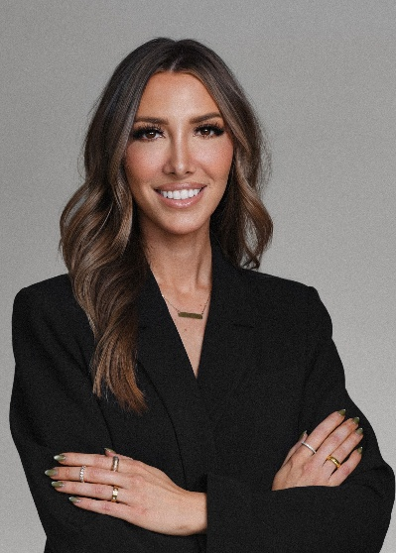
Dr. Sydney Brediger is originally from Washington, earning both undergraduate and DDS degrees from the UW. She is proud to continue training as a UW AEGD resident at Kaiser Permanente in Vancouver, WA. Before dental school, she practiced as a registered dental hygienist and remains dedicated to volunteer dentistry in underserved communities. Her professional interests include comprehensive dental care, with focuses on advanced restorative dentistry, endodontics, and esthetic smile design. Outside of the dentistry, she enjoys traveling, staying active, spending time with family, and adventuring with her maltipoo, Rosie.
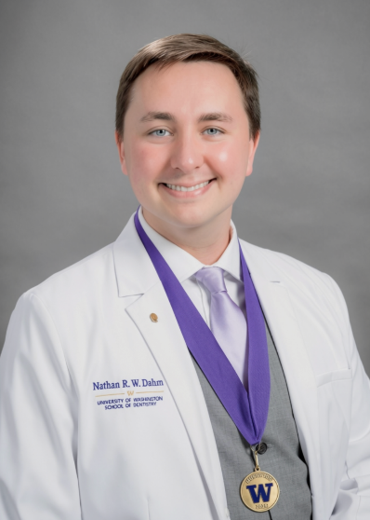
Dr. Nathan Dahm is from Issaquah, WA and earned both his BS and DDS degrees from the UW. He has 14 years of healthcare experience and is working on an MPH in Health Systems and Population Health in conjunction with his AEGD residency training. His professional interests include system-level advancements in healthcare and evidence-based restoration and reconstruction. Outside of healthcare, he is passionate about environmental sustainability, history, and architecture. He enjoys exploring the Pacific Northwest through hiking, camping, and wildlife observation, as well as sharing moments with friends and family.
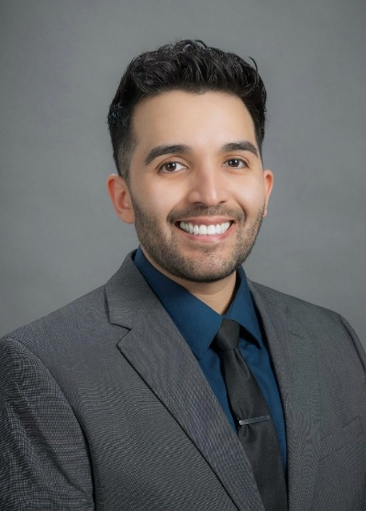
Dr. Edgar Gomez was raised in Washington and earned his DDS degree from UWSOD. He is excited to continue his training in the UW AEGD program, where he hopes to further develop his clinical skills while providing compassionate, comprehensive care to diverse patient populations. His professional interests include restorative dentistry, oral surgery, and community outreach. Outside of dentistry, Dr. Gomez enjoys playing soccer, strength training, caring for houseplants, and collecting Pokémon cards and vinyl records.

Welcome! … continued
Graduate Maxillofacial Prosthodontics Residents
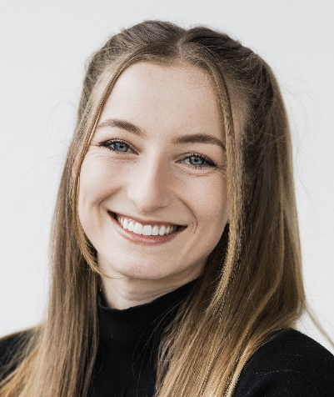
Dr. Elle Hansen is from Tacoma, WA, and attended dental school here at the University of Washington. Before dental school, she studied biology and global health and competed in track and field at Washington University in St. Louis. In her free time, Elle enjoys staying active outdoors, traveling, baking, and reading. Elle looks forward to her graduate training and getting to know her co-residents better.

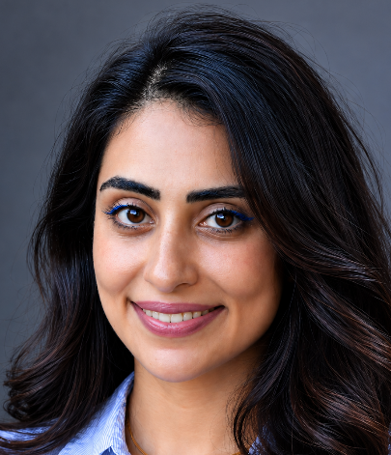
Dr. Nafiseh Afshar (Nah-fee-SHE) is from Iran, earning her DDS degree in 2018 and practiced in her own private office for several years before moving to the US. She recently completed her Master of Public Health degree. Her interests include oral health literacy, full-mouth rehabilitation, maxillofacial prosthodontics, and expanding access to oral healthcare through public health initiatives. She is excited to continue learning from both her colleagues and mentors. In her free time, she enjoys playing the dulcimer, cooking and baking, traveling, skiing, camping, and exploring the Pacific Northwest.

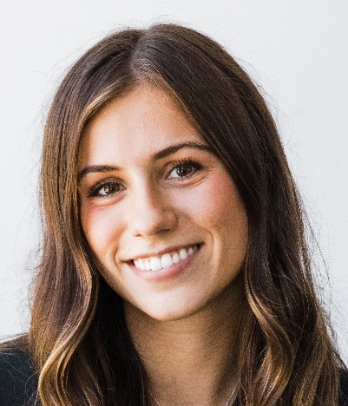
Dr. Rachel Wasyluka is from the suburbs of Seattle, WA, and earned her undergraduate degree from the University of Washington. She then moved to San Francisco to attend the University of the Pacific School of Dentistry, where she earned her dental degree and graduated in June 2026. In her free time, Rachel enjoys staying active and spending time outdoors. She is an avid hiker and enjoys skiing during the winter months. She also loves cooking, experimenting with new recipes, and playing card games with friends.

Welcome! … continued
Introduction of UW VISIT Researcher

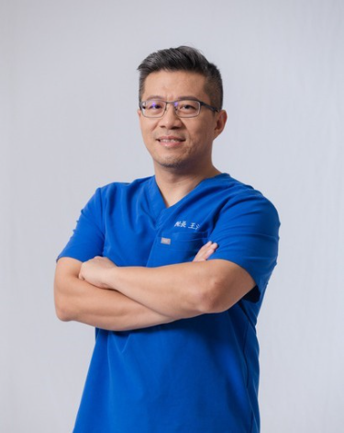
Dr. Fa-Jen (Josh) Wang is a Taiwan-based dentist visiting our Department of Restorative Dentistry as a PhD candidate under the UW VISIT program. He collaborates with Dr. Sadr on mechanical and optical characterization of 3D printed Zirconia. He is committed to lifelong learning and thoughtful professional exchange as the founder of Bonjour Dental Clinic in Taipei and the former President of the Taiwan Academy of Operative Dentistry. Dr. Wang also promotes responsible use of digital tools to improve education, clinical care, and patient experience. He believes dentistry is built on trust, kindness, and human connection. A proud father of two, he brings the same warmth from his family life into his practice, creating a welcoming environment where patients feel supported and cared for.
Dr. Josh Wang

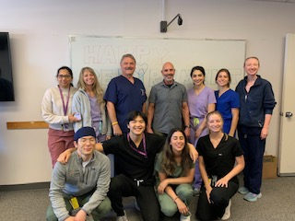
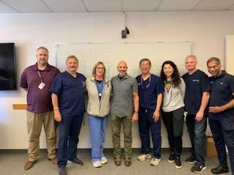
Faculty, staff, residents with Dr. Ramos

Farewell!

We held a send-off gathering for Dr. Van Ramos on Thursday, August 20. Many faculty members, including colleagues from other departments, as well as staff and residents, joined us to celebrate his retirement and wish him well. The event was filled with heartfelt conversations, well wishes, and plenty of photo opportunities as we reflected on his contributions and time with the program. Dr. Ramos will be greatly missed. We wish him all the best in his retirement and future endeavors. Good luck, Dr. Ramos!
Akiko Koyama

Congratulations!
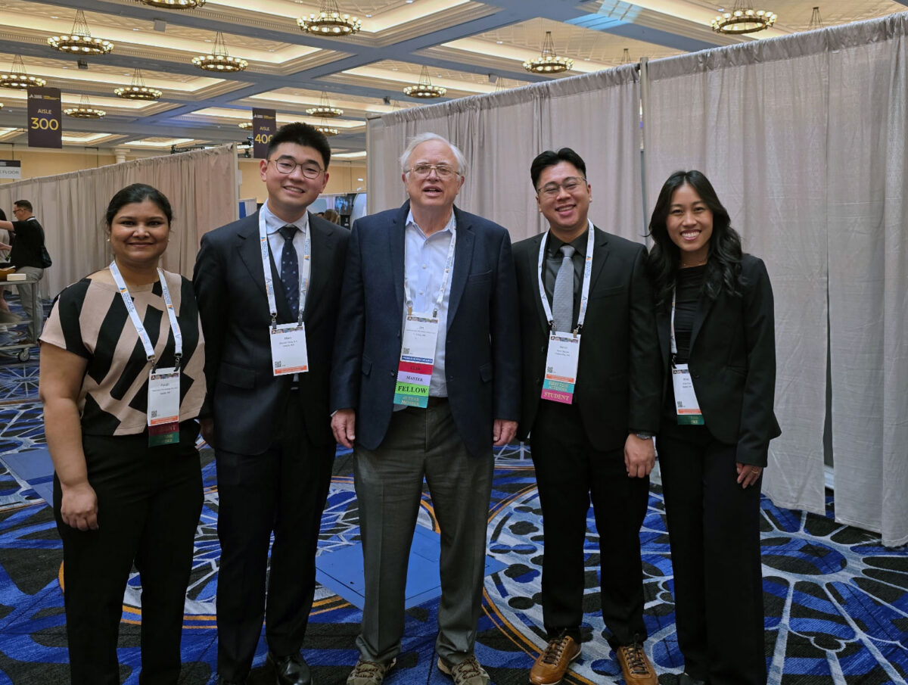
Dr. Newman with students presenting research
Faculty advisor Dr. Jim Newman and Chapter President Aaron Nguyen accompanied three other dental students to the Annual Academy of General Dentistry Meeting in Las Vegas, NV. Three students Mark Yang, Paridhi Garg, and Kristi Trinh presented their research. UW students Mark (’28) and Paridhi (27’) swept the Scientific Literature review category, winning first and second place.

Dr. Richard D. Tucker and Dr. Timmy Hess were pleased to represent UW Restorative Dentistry at the 2026 Annual Meeting of the Academy of R.V. Tucker Study Clubs (ARVTSC) in Maui, where they provided mentorship for the meeting’s clinical operations. They are proud to represent the UW School of Dentistry at professional gatherings such as the Tucker Academy’s annual meetings, the Academy of Operative Dentistry, and American Academy of Restorative Dentistry meetings in Chicago every February.
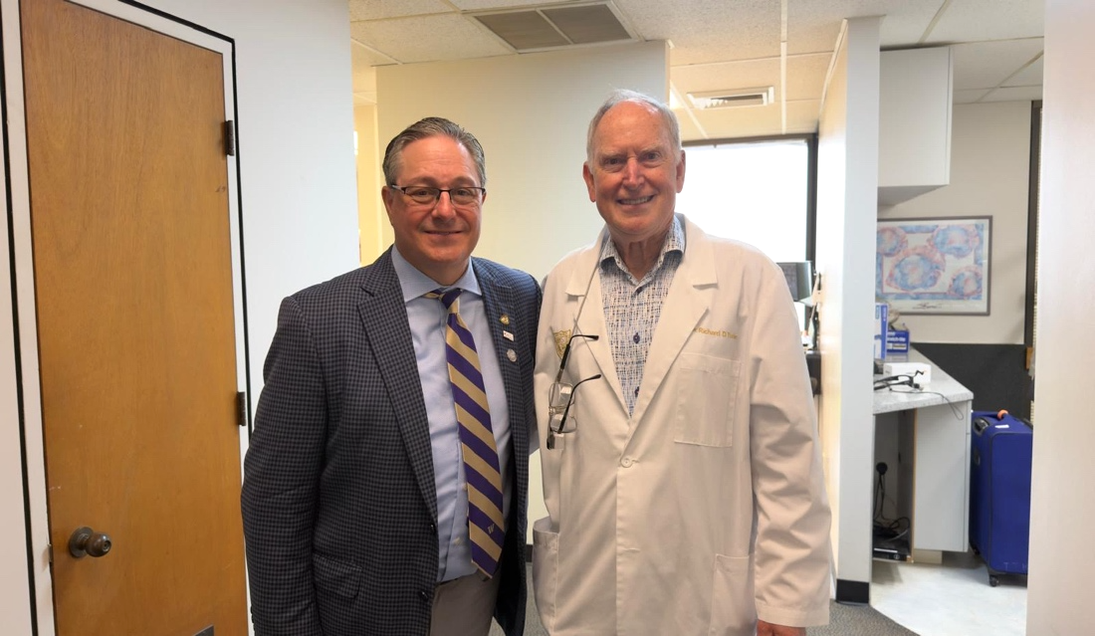
During the Maui meeting, Dr. Hess was introduced as the incoming President of ARVTSC for the coming year. This appointment is a tremendous honor, and he looks forward to representing the UWSOD through his leadership in this prestigious organization.
Dr. Hess and Dr. Tucker
Dr. Hess also currently serves as President of the Canadian Academy of Restorative Dentistry and Prosthodontics. Their upcoming meetings will be held in Halifax from Sept. 25-27, 2026. Those interested in attending may use the discount code CARDPSPECIAL to reduce the registration fee to $1,500 CAD. Registration can be completed at www.cardp.org.

Presentations!

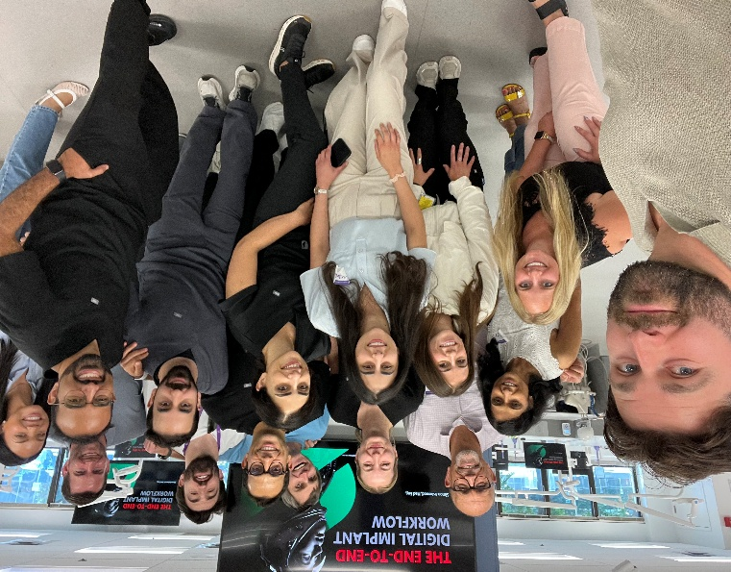
Straumann offered hands-on training on their UN!Q system on Saturday, July 18. There were two sessions (morning and afternoon), each accommodating up to 15 participants. The training was located at the D1 pre-clinical laboratory. Simon Ashwood, a Biomedical Engineer from Straumann, was presenting on integrated advanced digital workflow from guided implant planning and 3D printing to practice management system. Restorative, Periodontist, and Oral Surgery faculty and residents attended this workshop. Thank you Straumann (Justin Hoover and Jaya Jenkins) for supporting this event. Thanks also go to Dr. Sami Dogan for coordinating this event.
Straumann staff, Dr. Dogan, and dental residents

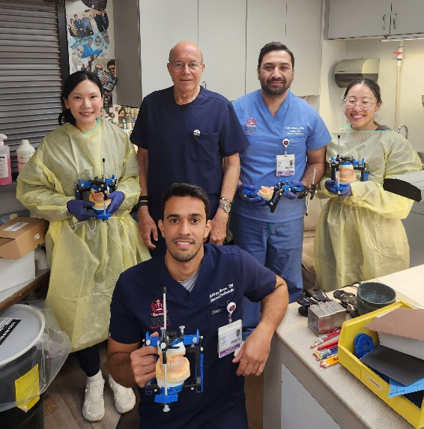
Dr. Schwedhelm with residents
Dr. Ricardo Schwedhelm taught an Immediate Denture Course on August 20-21, 2026, at Loma Linda University. The course provided hands-on clinical instruction and lectures to three Graduate Prosthodontics residents and one Implant Dentistry resident. Dr. Schwedhelm has been leading this course for the past ten years, demonstrating his longstanding commitment to resident education and excellence in prosthodontic training.

Spreading the UW Name Around the World

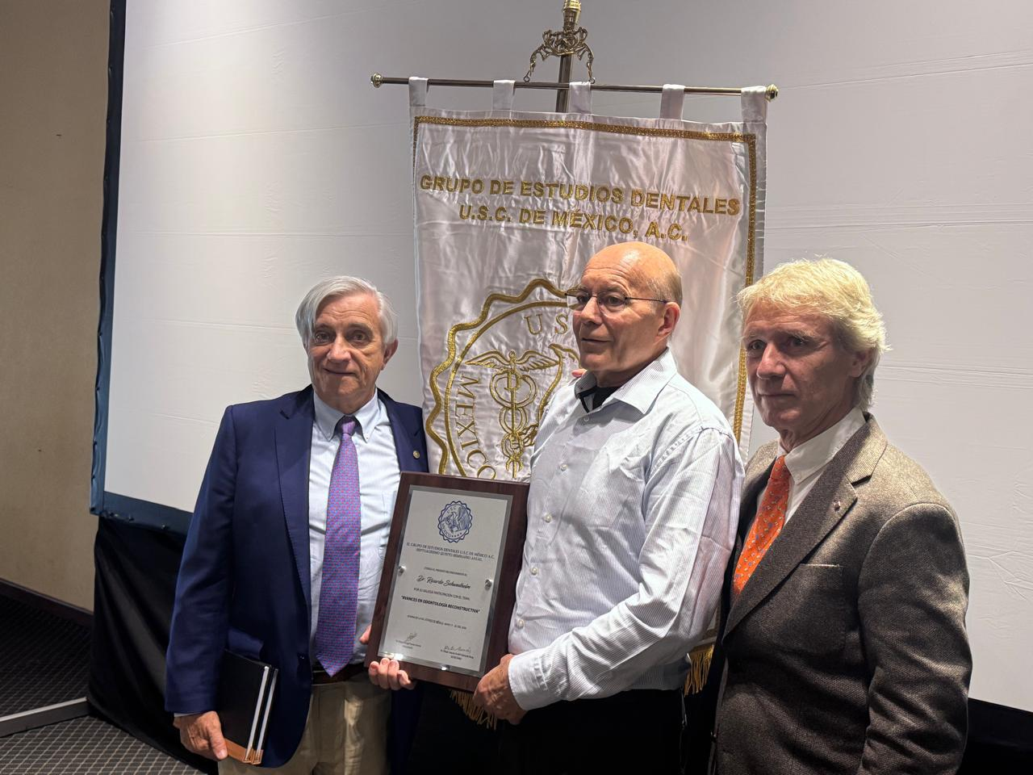
Dr. Ricardo Schwedhelm was invited to present at the El Grupo de Estudios Dentales USC de México meeting in Ixtapa, México from May 17-20, 2026. His lecture series, “Advances in Reconstructive Dentistry,” addressed several contemporary topics in Restorative and Prosthodontic Dentistry: Tooth Restorability Assessment, Implants versus Endodontic Therapy, Immediate Dentures and Removable Denture Prosthodontics, Update of Dental Cements, Diagnosis and Management of Restorative Implant Complications, and the Treatment of Fractured Teeth. The presentations provided clinicians with evidence-based approaches and practical strategies for managing complex restorative cases and optimizing long-term treatment outcomes.
Dr. Schwedhelm presented in Mexico
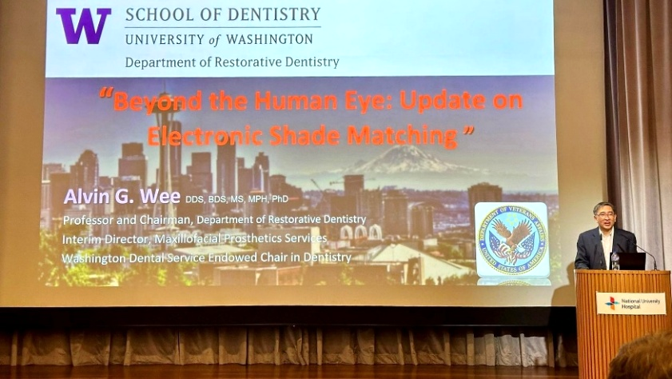
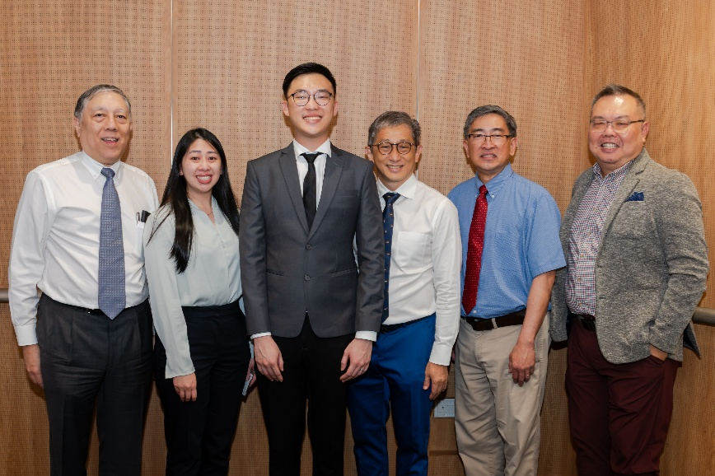
Dr. Wee’s presentation lecture
Dr. Wee with faculty and residents
Dr. Alvin Wee was invited to be the external examiner for final oral examination for two prosthodontic residents in their Graduate Prosthodontic MSD program at the National University of Singapore in May 2026. During his time in Singapore, he was also invited to lecture in the National University of Singapore Dentistry Clinical Symposium on “Beyond the Human Eye: Update on Electronic Shade Matching.”

Spreading the UW Name Around the World … continued

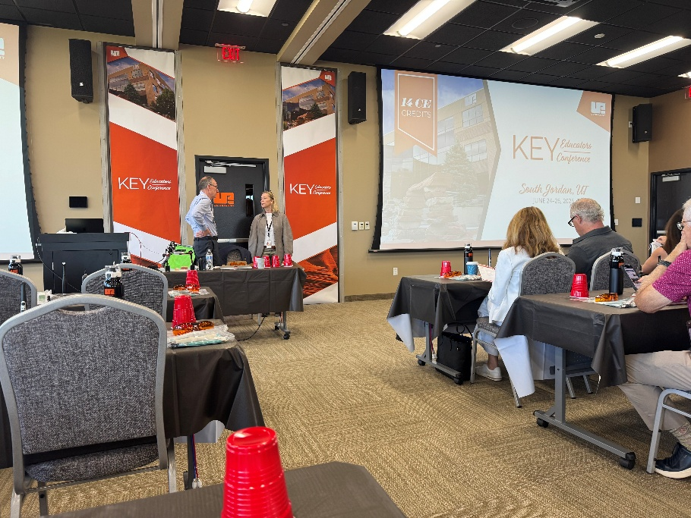
Dr. John Sorensen and Dr. Holly Lu attended the Ultradent Key Educators Conference held from June 24-26, 2026, in Salt Lake City. There was a hands-on exercise of composite restoration with Valo curing light conducted by Dr. Richard Price. The attendees toured the Ultradent facility to view the manufactural process of Valo light. Several International speakers presented topics: The Science of Teeth Whitening; Bonding and Restoratives; and Laser Science and Research. They enjoyed the conference dinner together with the rest of the attendees.
Ultradent Key Educators Conference

Department Social!
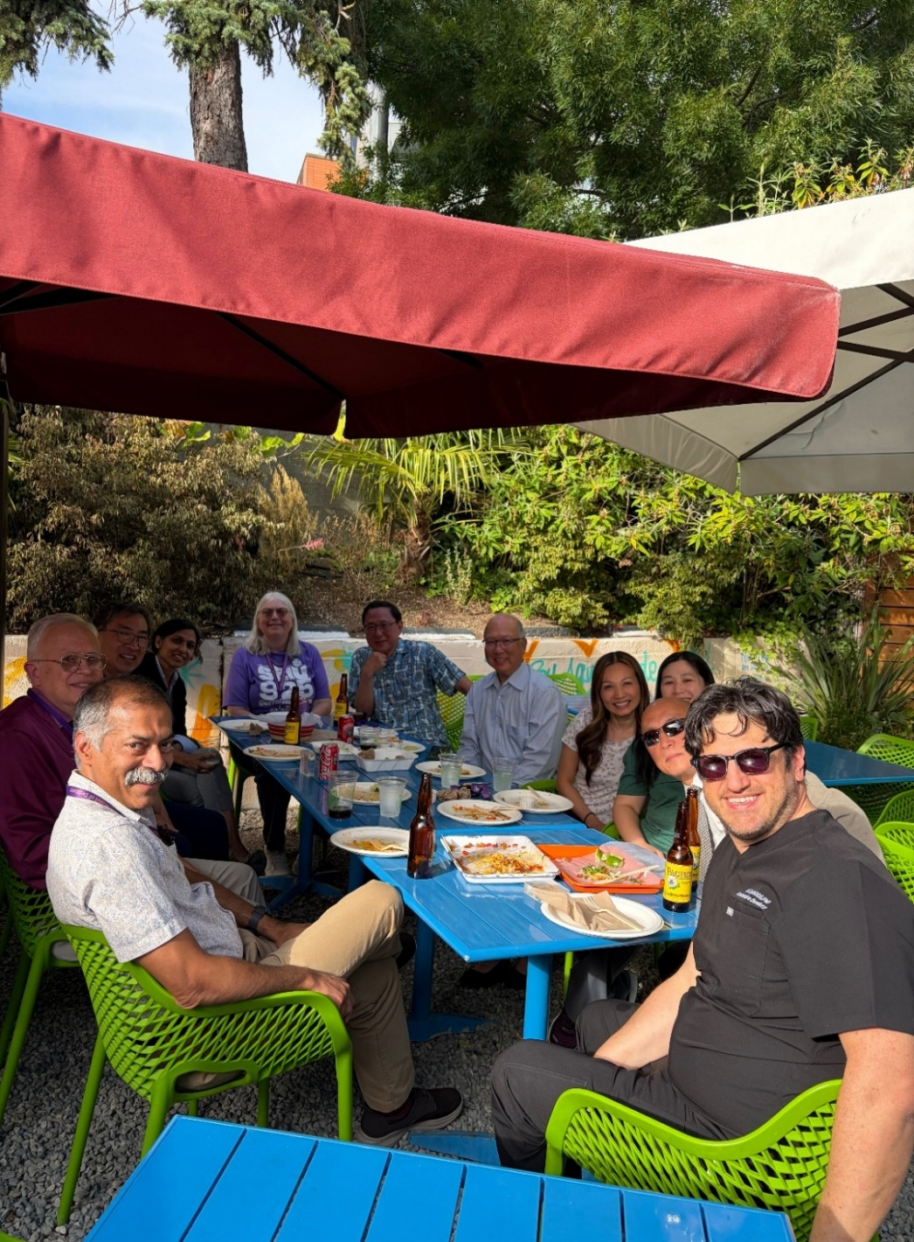
Faculty and staff attending social event at Agua Verde Cafe
On behalf of the Department Social Committee, Dr. Angela Chianglin organized a social event for faculty and staff. We gathered at Agua Verde Café on July 29, 2026. A handful of folks attended this fun event. It was a great getting together and relaxing event after a long day of working.

Publications / Abstracts

- Chen YW, Xu W, Sadr A, Nagatomo K, Porter G, Scher IS, Wang IC, Shen IY: Feasibility of Using a Flex Constant to Monitor Implant Stability Changes in a Porcine Model. Sensor 2026; 26:5516.
- Chandra SR, Wee AG, Moy PK, Haers PE, Sethi A, Blackburn T, Nayar S, Terheyden H: Guidelines, Consensus Statements, Position Papers, and Methodology in Maxillofacial Reconstructive Surgery and Rehabilitation: A Literature Review. International Journal of Maxillofacial Oral Implantology 2026; 1: on-line.
- Wadhwani CPK, Hess D, Chung KH, Rubenstein J: Abutment screw payload verification: Calculation using tightening-torque, loosening torque, and screw thread pitch versus actual measurement. J Prosthet Dent - Accepted
- Yadav S, Ponnamaneni N, Prasad S, Wee AG: Perspective and challenges in oral cancer screening practices of primary care providers. Oral – Accepted
- Aung MM, Lee YC, Peng TY, Lee IT, Chen YW, Lai PC, Feng SW. Artificial Intelligence-Assisted Diagnosis of Dental Caries and Periodontitis on Periapical Radiographs: A Clinical Validation Study. BMC Med Inform Decis Mak. 2026 Sep. - Accepted



Happy Birthday!
August
Dr. James Newman
Chris Toney

We wish you a happy birthday, and hope your day was wonderful!
If you would like your birthday included in the newsletter, send
the month to Vincent at vinn@uw.edu.

Editor: Dr. Alvin G. Wee
Design & Layout Editing: Vincent Tran
Copy Editing: Chris Toney

